UNITED STATES
SECURITIES AND EXCHANGE COMMISSION
WASHINGTON, D.C. 20549
____________________________________
FORM 8-K
____________________________________
CURRENT REPORT
PURSUANT TO SECTION 13 OR 15(D)
OF THE SECURITIES EXCHANGE ACT OF 1934
Date of Report (Date of Earliest Event Reported): July 22, 2026
____________________________________
WESTINGHOUSE AIR BRAKE TECHNOLOGIES
CORPORATION
(Exact name of registrant as specified in its charter)
____________________________________
Delaware
(State or other jurisdiction
of incorporation or organization)
033-90866 |  |  |  |  |  |  |  |  | 25-1615902
(Commission  File No.) |  |  |  |  |  |  |  |  | (I.R.S. Employer  Identification No.)
30 Isabella Street |  |  |  |  |  |  |  |  | 15212
Pittsburgh, PA |  |  |  |  |  |  |  |  | (Zip code)
(Address of principal executive offices)
412-825-1000
(Registrant’s telephone number, including area code)
Not Applicable
(Former name or former address, if changed since last report)
____________________________________
Check the appropriate box below if the Form 8-K filing is intended to simultaneously satisfy the filing obligation of the registrant under any of the following provisions (see General Instruction A.2.):
☐ |  |  | Written communications pursuant to Rule 425 under the Securities Act (17 CFR 230.425)
☐ |  |  | Soliciting material pursuant to Rule 14a-12 under the Exchange Act (17 CFR 240.14a-12)
☐ |  |  | Pre-commencement communications pursuant to Rule 14d-2(b) under the Exchange Act (17 CFR 240.14d-2(b))
☐ |  |  | Pre-commencement communications pursuant to Rule 13e-4(c) under the Exchange Act (17 CFR 240.13e-4(c))
Securities registered pursuant to Section 12(b) of the Act:
Class |  |  | Trading Symbol(s) |  |  | Name of each exchange on which registered
Common Stock, $.01 par value per share |  |  | WAB |  |  | New York Stock Exchange
Indicate by check mark whether the registrant is an emerging growth company as defined in Rule 405 of the Securities Act of 1933 (§230.405 of this chapter) or Rule 12b-2 of the Securities Exchange Act of 1934 (§240.12b-2 of this chapter).
Emerging growth company ☐
If an emerging growth company, indicate by check mark if the registrant has elected not to use the extended transition period for complying with any new or revised financial accounting standards provided pursuant to Section 13(a) of the Exchange Act. ☐

Item 2.02 |  |  | Results of Operations and Financial Condition
On July 22, 2026, Westinghouse Air Brake Technologies Corporation (the “Company”) issued a press release reporting, among other things, the Company’s 2026 second quarter results. A copy of this press release is attached as Exhibit 99.1 to this Current Report on Form 8-K and is incorporated into this Item 2.02 by reference. The Company is also furnishing an investor presentation relating to its second quarter of 2026 (the “Presentation”), which will be used by the management team for presentations to investors and others. A copy of the Presentation is attached hereto as Exhibit 99.2 and incorporated into this Item 2.02 by reference. The Presentation is also available on the Company’s website at www.wabteccorp.com.
In accordance with General Instruction B.2 of Form 8-K, the information furnished pursuant to this Item 2.02 in this Current Report on Form 8-K, including Exhibits 99.1 and 99.2, shall not be deemed “filed” for the purposes of Section 18 of the Securities Exchange Act of 1934, as amended, or otherwise subject to the liability of that section, nor shall it be deemed incorporated by reference in any filing under the Securities Act of 1933, as amended, except as shall be expressly set forth by specific reference in such a filing.

Item 7.01. |  |  | Regulation FD Disclosure
On July 22, 2026, the Company issued a press release which, among other things, provided earnings guidance for fiscal year 2026. A copy of the press release is attached to this report as Exhibit 99.1 and the paragraph under the heading “2026 Financial Guidance” which discusses 2026 guidance is incorporated into this Item 7.01 by reference. The Company also furnished a Presentation relating to its second quarter of 2026, which is incorporated into this Item 7.01 by reference. A copy of the Presentation is attached to this report as Exhibit 99.2.
In accordance with General Instruction B.2 of Form 8-K, the information furnished pursuant to this Item 7.01 in this Current Report on Form 8-K, including Exhibits 99.1 and 99.2, shall not be deemed “filed” for the purposes of Section 18 of the Securities Exchange Act of 1934, as amended, or otherwise subject to the liability of that section, nor shall it be deemed incorporated by reference in any filing under the Securities Act of 1933, as amended, except as shall be expressly set forth by specific reference in such a filing.

Item 9.01. |  |  | Financial Statements and Exhibits
(d) Exhibits.
The following exhibits are furnished with this report on Form 8-K:
Exhibit No. |  |  | Description
99.1 |  |  | Press release dated July 22, 2026
99.2 |  |  | Wabtec Earnings Presentation, Second Quarter 2026
104 |  |  | Cover Page Interactive Data File (embedded within the Inline XBRL document)
Caution Concerning Forward-Looking Statements
This communication contains “forward-looking” statements as that term is defined in Section 27A of the Securities Act of 1933 and Section 21E of the Securities Exchange Act of 1934, as amended by the Private Securities Litigation Reform Act of 1995. All statements, other than historical facts, including statements regarding Wabtec’s plans, objectives, expectations and intentions; Wabtec’s expectations about future sales, earnings and cash conversion; Wabtec’s projected expenses and cost savings associated with its Integration 2.0 and 3.0 initiatives and its portfolio optimization; Wabtec’s 5-year outlook; Wabtec’s expectations for evolving global industry, market and macro-economic conditions and their impact on Wabtec’s business; synergies and other expected benefits from Wabtec’s acquisitions; Wabtec’s expectations for production and demand conditions; and any assumptions underlying any of the foregoing, are forward looking statements. Forward-looking statements concern future circumstances and results and other statements that are not historical facts and are sometimes identified by the words “may,” “will,” “should,” “potential,” “intend,” “expect,” “endeavor,” “seek,” “anticipate,” “estimate,” “overestimate,” “underestimate,” “believe,” “could,” “project,” “predict,” “continue,” “target” or other similar words or expressions. Forward-looking statements are based upon current plans, estimates and expectations that are subject to risks, uncertainties and assumptions. Should one or more of these risks or uncertainties materialize, or should underlying assumptions prove incorrect, actual results may vary materially from those indicated or anticipated by such forward-looking statements. The inclusion of such statements should not be regarded as a representation that such plans, estimates or expectations will be achieved. Important factors that could cause actual results to differ materially from such plans, estimates or expectations include, among others, (1) changes in general economic and/or industry specific conditions, including the impacts of significant recent shifts in trade policies (including the actual or threatened imposition of tariffs and retaliatory tariff measures) as well as tax programs, inflation, supply chain disruptions, foreign currency exchange and industry consolidation and market reactions to these factors;

(2) changes in the financial condition or operating strategies of Wabtec's customers; (3) unexpected costs, charges or expenses resulting from acquisitions and potential failure to realize synergies and other anticipated benefits of acquisitions, including as a result of integrating acquired targets into Wabtec; (4) inability to retain and hire key personnel; (5) evolving legal, regulatory and tax regimes; (6) changes in the expected timing of projects; (7) a decrease in freight or passenger rail traffic; (8) an increase in manufacturing costs; (9) actions by third parties, including government agencies; (10) the impacts of epidemics, pandemics, or similar public health crises on the global economy and, in particular, our customers, suppliers and end-markets, (11) potential disruptions, instability, and volatility in global markets as a result of global military action, acts of terrorism or armed conflict, including Russia’s invasion of Ukraine and ongoing military conflicts in the Middle East; (12) cybersecurity and data protection risks and (13) other risk factors as detailed from time to time in Wabtec’s reports filed with the SEC, including Wabtec’s annual report on Form 10-K, periodic quarterly reports on Form 10-Q, current reports on Form 8-K and other documents filed with the SEC. The foregoing list of important factors is not exclusive. Any forward-looking statements speak only as of the date of this communication. Wabtec does not undertake any obligation to update any forward-looking statements, whether as a result of new information or development, future events or otherwise, except as required by law. Readers are cautioned not to place undue reliance on any of these forward-looking statements.

SIGNATURES
Pursuant to the requirements of Securities Exchange Act of 1934, the Company has duly caused this report to be signed on its behalf by the undersigned thereunto duly authorized.
WESTINGHOUSE AIR BRAKE TECHNOLOGIES CORPORATION
By: |  |  | /s/ JOHN A. OLIN
 |  |  | John A. Olin
Executive Vice President and
Chief Financial Officer
(Duly Authorized Officer and Principal Financial Officer)
DATE: |  |  | July 22, 2026



Exhibit 99.1

Wabtec Reports Strong Second Quarter 2026 Results
Announces Increase to Full-Year Revenue & Adjusted EPS Guidance

SALES |  |  |  |  |  |  |  |  | GAAP DILUTED  EARNINGS PER SHARE |  |  |  |  |  |  |  |  | ADJUSTED DILUTED  EARNINGS PER SHARE
2Q’26 |  |  | First Half ‘26 |  |  |  |  |  | 2Q’26 |  |  | First Half ‘26 |  |  |  |  |  | 2Q’26 |  |  | First Half ‘26
$3.18B |  |  | $6.13B |  |  |  |  |  | $2.33 |  |  | $4.44 |  |  |  |  |  | $2.76 |  |  |  |  |  | $5.46
+17.5% YOY |  |  | +15.3%YOY |  |  |  |  |  | +18.9% YOY |  |  | +15.6% YOY |  |  |  |  |  | +21.6% YOY |  |  |  |  |  | +20.0% YOY

Q2 2026 HIGHLIGHTS

“Wabtec delivered a strong first half, with solid second quarter execution across our businesses driving robust sales growth, margin expansion and a 22% increase in adjusted EPS growth,” said Rafael Santana, Wabtec’s Chairman and CEO.
“The strength of our performance reflects the resilience of our portfolio, the impact of our innovative solutions and the disciplined execution from our teams. During the quarter, we continued to build momentum through strategic commercial awards and the successful integrations of our recent acquisitions, further enhancing our market position and expanding our long-term growth opportunities.
“With a strong foundation, a talented global team, and significant opportunities ahead, we are well positioned to deliver profitable growth and continue to compound shareholder value.”
Rafael Santana Chairman and CEO

•Sales Growth of 17.5% to $3.18 Billion Driven by Both the Freight and Transit Segments

•GAAP Operating Margin at 18.9%; Adjusted Operating Margin Up 0.8 pts to 21.9%

•Strong Multi-year Backlog at $30.93 Billion; 12-month Backlog Growth at 11.3%

•GAAP Earnings Per Share of $2.33, Up 18.9%; Adjusted Earnings Per Share of $2.76, Up 21.6%

PITTSBURGH, July 22, 2026 – Wabtec Corporation (NYSE: WAB) today reported second quarter 2026 GAAP earnings per diluted share of $2.33, up 18.9% versus the second quarter of 2025. Adjusted earnings per diluted share were $2.76, up 21.6% versus the same quarter a year ago. Second quarter sales were $3.18 billion and cash from operations was $441 million.

2026 Second Quarter Consolidated Results
Wabtec Corporation Consolidated Financial Results
$ in millions except earnings per share and percentages; margin change in percentage points (pts) |  |  | Second Quarter
 |  |  | 2026 |  |  | 2025 |  |  | Change
Net Sales |  |  | $3,179 |  |  | $2,706 |  |  | 17.5 |  | %
GAAP Gross Margin |  |  | 36.5 |  | % | 34.7 |  | % | 1.8 pts
Adjusted Gross Margin |  |  | 36.7 |  | % | 34.8 |  | % | 1.9 pts
GAAP Operating Margin |  |  | 18.9 |  | % | 17.4 |  | % | 1.5 pts
Adjusted Operating Margin |  |  | 21.9 |  | % | 21.1 |  | % | 0.8 pts
GAAP Diluted EPS |  |  | $2.33 |  |  | $1.96 |  |  | 18.9 |  | %
Adjusted Diluted EPS |  |  | $2.76 |  |  | $2.27 |  |  | 21.6 |  | %
Cash Flow from Operations |  |  | $441 |  |  | $209 |  |  | $232
Operating Cash Flow Conversion |  |  | 82 |  | % | 46 |  | %

•Sales increased 17.5% compared to the year-ago quarter driven by higher sales in the Freight and Transit segments, which includes the acquisitions of Inspection Technologies, Frauscher Sensor Technologies, and Dellner Couplers.
•GAAP operating margin was higher than the prior year at 18.9%, and adjusted operating margin was higher than the prior year at 21.9%. Both GAAP and adjusted operating margins benefited from robust sales growth and improved gross margins in the quarter.
•GAAP EPS and adjusted EPS increased from the year-ago quarter primarily due to higher sales and operating margin expansion.

2026 Second Quarter Freight Segment Results
Wabtec Corporation Freight Segment Financial Results
Net sales $ in millions; margin change in percentage points (pts) |  |  | Second Quarter
 |  |  | 2026 |  |  | 2025 |  |  | Change
Net Sales |  |  | $2,243 |  |  | $1,919 |  |  | 16.9 |  | %
GAAP Gross Margin |  |  | 38.1 |  | % | 36.3 |  | % | 1.8 pts
Adjusted Gross Margin |  |  | 38.1 |  | % | 36.4 |  | % | 1.7 pts
GAAP Operating Margin |  |  | 22.5 |  | % | 21.6 |  | % | 0.9 pts
Adjusted Operating Margin |  |  | 25.8 |  | % | 25.0 |  | % | 0.8 pts

•Freight segment sales for the second quarter were up 16.9%. Equipment sales were up 35.0% driven by higher locomotive deliveries, while Services sales were down 4.2% due to lower modernization deliveries, as expected. Digital sales were up 88.5% driven by the acquisitions of Inspection Technologies and Frauscher Sensor Technologies.
•GAAP and adjusted operating margin benefited from gross margin improvements which was partially offset by higher operating expenses as a percentage of revenue.

2026 Second Quarter Transit Segment Results
Wabtec Corporation Transit Segment Financial Results
Net sales $ in millions; margin change in percentage points (pts) |  |  | Second Quarter
 |  |  | 2026 |  |  | 2025 |  |  | Change
Net Sales |  |  | $936 |  |  | $787 |  |  | 18.9 |  | %
GAAP Gross Margin |  |  | 32.8 |  | % | 30.7 |  | % | 2.1 pts
Adjusted Gross Margin |  |  | 33.3 |  | % | 30.9 |  | % | 2.4 pts
GAAP Operating Margin |  |  | 15.6 |  | % | 13.9 |  | % | 1.7 pts
Adjusted Operating Margin |  |  | 17.7 |  | % | 15.2 |  | % | 2.5 pts

•Transit segment sales for the second quarter were up 18.9% driven by the acquisition of Dellner Couplers, higher OE and aftermarket sales, and favorable foreign currency exchange. Sales were up 17.7% on a constant currency basis.
•GAAP and adjusted operating margins were up as a result of improved gross margins. GAAP gross margins were partially offset by higher operating expenses as a percent of revenue.

Backlog
Wabtec Corporation Consolidated Backlog Comparison
Backlog $ in millions |  |  | June 30,
 |  |  | 2026 |  |  | 2025 |  |  | Change
12-Month Backlog |  |  | $9,140 |  |  | $8,210 |  |  | 11.3 |  | %
Total Backlog |  |  | $30,932 |  |  | $21,828 |  |  | 41.7 |  | %

•The Company’s multi-year backlog continues to provide strong visibility. At June 30, 2026, the 12-month backlog was $0.93 billion higher than the prior year period. At June 30, 2026, the multi-year backlog was $9.10 billion higher than the prior year period, and excluding foreign currency exchange, the multi-year backlog was $9.02 billion higher, up 41.3%.

Cash Flow and Liquidity Summary
•During the second quarter, the Company generated cash from operations of $441 million versus $209 million in the year ago period. The increase in cash was driven by higher net income and favorable working capital.
•At the end of the quarter, the Company had cash, cash equivalents and restricted cash of $0.67 billion and total debt of $6.57 billion. At June 30, 2026, the Company’s total available liquidity was $2.02 billion, which includes $0.66 billion in cash and cash equivalents plus $1.36 billion available under current credit facilities.
•During the quarter, the Company repurchased $215 million of Wabtec shares and paid $53 million in dividends.

2026 Financial Guidance
•Wabtec increased its 2026 revenue guidance range to $12.30 billion to $12.60 billion, raising it $110 million at the midpoint, or up 11.5% versus prior year.
•Wabtec increased its 2026 adjusted EPS guidance range to $10.60 - $10.90, raising it $0.30 at the midpoint, or up 19.9% versus prior year.

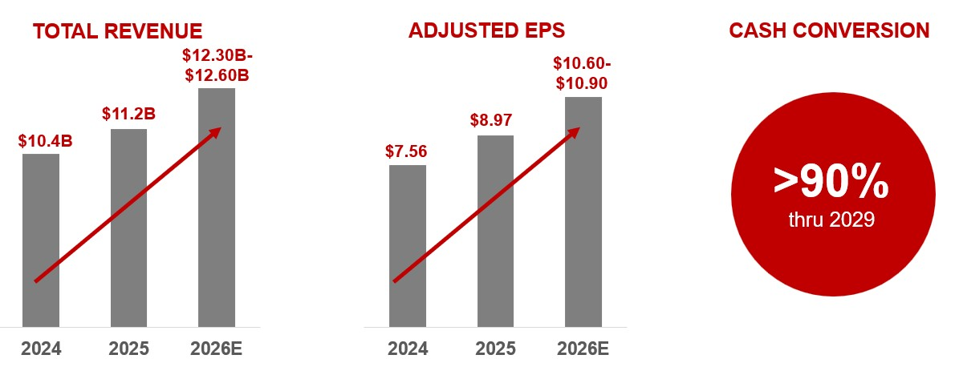

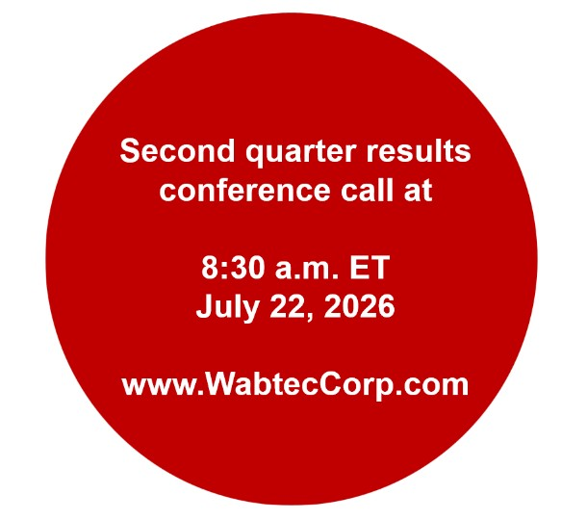

About Wabtec
Wabtec Corporation (NYSE: WAB) is revolutionizing the way the world moves for future generations. The company is a leading global provider of equipment, systems, digital solutions and value-added services for the freight and transit rail industries, as well as the mining, marine and industrial markets. Wabtec has been a leader in the rail industry for over 155 years and has a vision to achieve a sustainable rail system in the U.S. and worldwide. Visit Wabtec’s website at www.wabteccorp.com.

Forecasted GAAP Earnings Reconciliation
Wabtec is not presenting a quantitative reconciliation of our forecasted GAAP earnings per diluted share to forecasted adjusted earnings per diluted share because it is unable to predict with reasonable certainty and without unreasonable effort the impact and timing of restructuring-related and other charges, including acquisition-related expenses and the outcome of certain regulatory, legal and tax matters. The financial impact of these items is uncertain and is dependent on various factors, including timing, and could be material to our Consolidated Statements of Earnings.

Conference Call Information
Wabtec will host a call with analysts and investors at 8:30 a.m. ET, today. To listen via webcast, go to Wabtec’s website at www.WabtecCorp.com and click on “Events & Presentations” in the “Investor Relations” section. Also, an audio replay of the call will be available by calling 1-855-669-9658 or 1-412-317-0088 (access code: 2758919).

Information about non-GAAP Financial Information and Forward-Looking Statements
Wabtec’s earnings release and 2026 financial guidance mentions certain non-GAAP financial performance measures, including adjusted gross profit, adjusted operating expenses, adjusted operating margin, adjusted gross margin, EBITDA, adjusted EBITDA, adjusted income tax expense, adjusted income from operations, adjusted interest and other expense, adjusted net income, adjusted earnings per diluted share and operating cash flow conversion. Wabtec defines EBITDA as earnings before interest, taxes, depreciation and amortization. Adjusted EBITDA is further adjusted by restructuring costs. Wabtec defines operating cash flow conversion as net cash provided by operating activities divided by net income plus depreciation and amortization including deferred debt cost amortization. While Wabtec believes these are useful supplemental measures for investors, they are not presented in accordance with GAAP. Investors should not consider non-GAAP measures in isolation or as a substitute for net income, cash flows from operations, or any other items calculated in accordance with GAAP. In addition, the non-GAAP financial measures included in this release have inherent material limitations as performance measures because they add back certain expenses incurred by the Company to GAAP financial measures, resulting in those expenses not being taken into account in the applicable non-GAAP financial measure. Because not all companies use identical calculations, Wabtec’s presentation of non-GAAP financial measures may not be comparable to other similarly titled measures of other companies. Included in this release are reconciliation tables that provide details about how adjusted results relate to GAAP results.

This communication contains “forward-looking” statements as that term is defined in Section 27A of the Securities Act of 1933, and Section 21E of the Securities Exchange Act of 1934, as amended by the Private Securities Litigation Reform Act of 1995. All statements, other than historical facts, including statements regarding Wabtec’s plans, objectives, expectations and intentions; Wabtec’s expectations about future sales, earnings and cash conversion; and any assumptions underlying any of the foregoing, are forward-looking statements. Forward-looking statements concern future circumstances and results and other statements that are not historical facts and are sometimes identified by the words “may,” “will,” “should,” “potential,” “intend,” “expect,” “endeavor,” “seek,” “anticipate,” “estimate,” “overestimate,” “underestimate,” “believe,” “could,” “project,” “predict,” “continue,” “target” or other similar words or expressions. Forward-looking statements are based upon current plans, estimates and expectations that are subject to risks, uncertainties and assumptions. Should one or more of these risks or uncertainties materialize, or should underlying assumptions prove incorrect, actual results may vary materially from those indicated or anticipated by such forward-looking statements. The inclusion of such statements should not be regarded as a representation that such plans, estimates or expectations will be achieved. Important factors that could cause actual results to differ materially from such plans, estimates or expectations include, among others, (1) changes in general economic and/or industry specific conditions, including the impacts of significant recent shifts in trade policies (including the actual or threatened imposition of tariffs and retaliatory tariff measures) as well as tax programs, inflation, supply chain disruptions, foreign currency exchange and industry consolidation and market reactions to these factors; (2) changes in the financial condition or operating strategies of Wabtec’s customers; (3) unexpected costs, charges or expenses resulting from acquisitions and potential failure to realize synergies and other anticipated benefits of acquisitions, including as a result of integrating acquired targets into Wabtec; (4) inability to retain and hire key personnel; (5) evolving legal, regulatory and tax regimes; (6) changes in the expected timing of projects; (7) a decrease in freight or passenger rail traffic; (8) an increase in manufacturing costs; (9) actions by third parties, including government agencies; (10) the impacts of epidemics, pandemics or similar public health crises on the global economy and, in particular, our customers, suppliers and end-markets, (11) potential disruptions, instability and volatility in global markets as a result of global military action, acts of terrorism or armed conflict, including Russia’s invasion of Ukraine and ongoing military conflicts in the Middle East; (12) cybersecurity and data protection risks and (13) other risk factors as detailed from time to time in Wabtec’s reports filed with the SEC, including Wabtec’s annual report on Form 10-K, periodic quarterly reports on Form 10-Q, current reports on Form 8-K and other documents filed with the SEC. The foregoing list of important factors is not exclusive. Any forward-looking statements speak only as of the date of this communication. Wabtec does not undertake any obligation to update any forward-looking statements, whether as a result of new information or

development, future events or otherwise, except as required by law. Readers are cautioned not to place undue reliance on any of these forward-looking statements.

Wabtec Investor Contact
Kyra Yates / Kyra.Yates@wabtec.com / 817-349-2735

Wabtec Media Contact
Tim Bader / Tim.Bader@wabtec.com / 682-319-7925

Appendix A
WESTINGHOUSE AIR BRAKE TECHNOLOGIES CORPORATION
CONDENSED CONSOLIDATED STATEMENTS OF INCOME
FOR THE THREE AND SIX MONTHS ENDED JUNE 30, 2026 AND 2025
(AMOUNTS IN MILLIONS EXCEPT PER SHARE DATA)
(UNAUDITED)
 |  |  | Three Months Ended  June 30, |  |  |  |  |  |  |  |  |  |  |  | Six Months Ended  June 30,
 |  |  | 2026 |  |  |  |  |  | 2025 |  |  |  |  |  | 2026 |  |  |  |  |  | 2025
Net sales |  |  | $ | 3,179 |  |  |  |  | $ | 2,706 |  |  |  |  | $ | 6,129 |  |  |  |  | $ | 5,316
Cost of sales |  |  | (2,018) |  |  |  |  |  | (1,768) |  |  |  |  |  | (3,907) |  |  |  |  |  | (3,478)
Gross profit |  |  | 1,161 |  |  |  |  |  | 938 |  |  |  |  |  | 2,222 |  |  |  |  |  | 1,838
Gross profit as a % of Net sales |  |  | 36.5 |  | % |  |  |  | 34.7 |  | % |  |  |  | 36.2 |  | % |  |  |  | 34.6 |  | %
Selling, general and administrative expenses |  |  | (400) |  |  |  |  |  | (347) |  |  |  |  |  | (801) |  |  |  |  |  | (654)
Engineering expenses |  |  | (70) |  |  |  |  |  | (50) |  |  |  |  |  | (126) |  |  |  |  |  | (96)
Amortization expense |  |  | (91) |  |  |  |  |  | (69) |  |  |  |  |  | (178) |  |  |  |  |  | (142)
Total operating expenses |  |  | (561) |  |  |  |  |  | (466) |  |  |  |  |  | (1,105) |  |  |  |  |  | (892)
Operating expenses as a % of Net sales |  |  | 17.6 |  | % |  |  |  | 17.2 |  | % |  |  |  | 18.0 |  | % |  |  |  | 16.8 |  | %
Income from operations |  |  | 600 |  |  |  |  |  | 472 |  |  |  |  |  | 1,117 |  |  |  |  |  | 946
Income from operations as a % of Net sales |  |  | 18.9 |  | % |  |  |  | 17.4 |  | % |  |  |  | 18.2 |  | % |  |  |  | 17.8 |  | %
Interest expense, net |  |  | (80) |  |  |  |  |  | (46) |  |  |  |  |  | (151) |  |  |  |  |  | (92)
Other (expense) income, net |  |  | (2) |  |  |  |  |  | 24 |  |  |  |  |  | 21 |  |  |  |  |  | 22
Income before income taxes |  |  | 518 |  |  |  |  |  | 450 |  |  |  |  |  | 987 |  |  |  |  |  | 876
Income tax expense |  |  | (122) |  |  |  |  |  | (111) |  |  |  |  |  | (228) |  |  |  |  |  | (210)
Effective tax rate |  |  | 23.4 |  | % |  |  |  | 24.8 |  | % |  |  |  | 23.1 |  | % |  |  |  | 24.0 |  | %
Net income |  |  | 396 |  |  |  |  |  | 339 |  |  |  |  |  | 759 |  |  |  |  |  | 666
Less: Net income attributable to noncontrolling interest |  |  | (1) |  |  |  |  |  | (3) |  |  |  |  |  | (2) |  |  |  |  |  | (8)
Net income attributable to Wabtec shareholders |  |  | $ | 395 |  |  |  |  | $ | 336 |  |  |  |  | $ | 757 |  |  |  |  | $ | 658
Earnings Per Common Share
Basic
Net income attributable to Wabtec shareholders |  |  | $ | 2.33 |  |  |  |  | $ | 1.96 |  |  |  |  | $ | 4.45 |  |  |  |  | $ | 3.84
Diluted
Net income attributable to Wabtec shareholders |  |  | $ | 2.33 |  |  |  |  | $ | 1.96 |  |  |  |  | $ | 4.44 |  |  |  |  | $ | 3.84
Weighted average shares outstanding
Basic |  |  | 169.1 |  |  |  |  |  | 170.6 |  |  |  |  |  | 169.5 |  |  |  |  |  | 170.6
Diluted |  |  | 169.6 |  |  |  |  |  | 171.2 |  |  |  |  |  | 170.1 |  |  |  |  |  | 171.2

Appendix A
WESTINGHOUSE AIR BRAKE TECHNOLOGIES CORPORATION
CONDENSED CONSOLIDATED STATEMENTS OF INCOME (CONTINUED)
FOR THE THREE AND SIX MONTHS ENDED JUNE 30, 2026 AND 2025
(AMOUNTS IN MILLIONS EXCEPT PER SHARE DATA)
(UNAUDITED)

 |  |  | Three Months Ended  June 30, |  |  |  |  |  |  |  |  |  |  |  | Six Months Ended  June 30,
 |  |  | 2026 |  |  |  |  |  | 2025 |  |  |  |  |  | 2026 |  |  |  |  |  | 2025
Segment Information
Freight Net sales |  |  | $ | 2,243 |  |  |  |  | $ | 1,919 |  |  |  |  | $ | 4,358 |  |  |  |  | $ | 3,820
Freight Income from operations |  |  | $ | 504 |  |  |  |  | $ | 415 |  |  |  |  | $ | 954 |  |  |  |  | $ | 835
Freight Operating margin |  |  | 22.5 |  | % |  |  |  | 21.6 |  | % |  |  |  | 21.9 |  | % |  |  |  | 21.9 |  | %
Transit Net sales |  |  | $ | 936 |  |  |  |  | $ | 787 |  |  |  |  | $ | 1,771 |  |  |  |  | $ | 1,496
Transit Income from operations |  |  | $ | 146 |  |  |  |  | $ | 109 |  |  |  |  | $ | 267 |  |  |  |  | $ | 199
Transit Operating margin |  |  | 15.6 |  | % |  |  |  | 13.9 |  | % |  |  |  | 15.1 |  | % |  |  |  | 13.3 |  | %
Backlog Information (Note: 12-month is a sub-set of total) |  |  | June 30, 2026 |  |  |  |  |  | March 31, 2026 |  |  |  |  |  | June 30, 2025
Freight Total |  |  | $ | 25,332 |  |  |  |  | $ | 25,175 |  |  |  |  | $ | 17,136
Transit Total |  |  | 5,600 |  |  |  |  |  | 5,627 |  |  |  |  |  | 4,692
Wabtec Total |  |  | $ | 30,932 |  |  |  |  | $ | 30,802 |  |  |  |  | $ | 21,828
Freight 12-month |  |  | $ | 6,638 |  |  |  |  | $ | 6,679 |  |  |  |  | $ | 6,024
Transit 12-month |  |  | 2,502 |  |  |  |  |  | 2,568 |  |  |  |  |  | 2,186
Wabtec 12-month |  |  | $ | 9,140 |  |  |  |  | $ | 9,247 |  |  |  |  | $ | 8,210

Appendix B
WESTINGHOUSE AIR BRAKE TECHNOLOGIES CORPORATION
CONDENSED CONSOLIDATED BALANCE SHEETS
(UNAUDITED)
 |  |  | June 30, 2026 |  |  |  |  |  | December 31, 2025
In millions
Cash, cash equivalents and restricted cash |  |  | $ | 670 |  |  |  |  | $ | 789
Receivables, net |  |  | 2,169 |  |  |  |  |  | 1,897
Inventories, net |  |  | 2,857 |  |  |  |  |  | 2,745
Other current assets |  |  | 345 |  |  |  |  |  | 263
Total current assets |  |  | 6,041 |  |  |  |  |  | 5,694
Property, plant and equipment, net |  |  | 1,653 |  |  |  |  |  | 1,616
Goodwill |  |  | 10,603 |  |  |  |  |  | 10,216
Other intangible assets, net |  |  | 4,122 |  |  |  |  |  | 3,838
Other noncurrent assets |  |  | 709 |  |  |  |  |  | 705
Total Assets |  |  | $ | 23,128 |  |  |  |  | $ | 22,069
Current liabilities |  |  | $ | 5,387 |  |  |  |  | $ | 5,150
Long-term debt |  |  | 4,915 |  |  |  |  |  | 4,291
Other long-term liabilities |  |  | 1,582 |  |  |  |  |  | 1,438
Total Liabilities |  |  | 11,884 |  |  |  |  |  | 10,879
Shareholders' equity |  |  | 11,214 |  |  |  |  |  | 11,142
Noncontrolling interest |  |  | 30 |  |  |  |  |  | 48
Total Equity |  |  | 11,244 |  |  |  |  |  | 11,190
Total Liabilities and Equity |  |  | $ | 23,128 |  |  |  |  | $ | 22,069

Appendix C
WESTINGHOUSE AIR BRAKE TECHNOLOGIES CORPORATION
CONDENSED CONSOLIDATED STATEMENTS OF CASH FLOWS
(UNAUDITED)
Six Months Ended
June 30,
 |  |  | 2026 |  |  |  |  |  | 2025
In millions
Operating activities
Net income |  |  | $ | 759 |  |  |  |  | $ | 666
Non-cash expense |  |  | 310 |  |  |  |  |  | 219
Receivables |  |  | (229) |  |  |  |  |  | (243)
Inventories |  |  | (35) |  |  |  |  |  | (180)
Accounts payable |  |  | 20 |  |  |  |  |  | 74
Other operating activities |  |  | (185) |  |  |  |  |  | (136)
Net cash provided by operating activities |  |  | 640 |  |  |  |  |  | 400
Net cash used for investing activities |  |  | (1,160) |  |  |  |  |  | (98)
Net cash provided by financing activities |  |  | 408 |  |  |  |  |  | 454
Effect of changes in currency exchange rates |  |  | (7) |  |  |  |  |  | 28
(Decrease) increase in cash |  |  | (119) |  |  |  |  |  | 784
Cash, cash equivalents and restricted cash, beginning of period |  |  | 789 |  |  |  |  |  | 715
Cash, cash equivalents and restricted cash, end of period |  |  | $ | 670 |  |  |  |  | $ | 1,499

Appendix D
Set forth below is the calculation of the non-GAAP performance measures included in this press release. We believe that these measures provide useful supplemental information to assess our operating performance and to evaluate period-to-period comparisons. Non-GAAP financial measures should be viewed in addition to, and not as an alternative for, Wabtec’s reported results prepared in accordance with GAAP.
Wabtec Corporation
Reconciliation of Reported Results to Adjusted Results
(in millions) |  |  |  |  |  | Second Quarter 2026 Actual Results
 |  |  |  |  |  | Net |  |  |  |  |  | Gross |  |  |  |  |  | Operating |  |  |  |  |  | Income from |  |  |  |  |  | Interest & |  |  |  |  |  |  |  |  |  |  |  | Net |  |  |  |  |  | Noncontrolling |  |  |  |  |  | Wabtec
 |  |  |  |  |  | Sales |  |  |  |  |  | Profit |  |  |  |  |  | Expenses |  |  |  |  |  | Operations |  |  |  |  |  | Other Exp |  |  |  |  |  | Tax |  |  |  |  |  | Income |  |  |  |  |  | Interest |  |  |  |  |  | Net Income |  |  |  |  |  | EPS
Reported Results |  |  |  |  |  | $ | 3,179 |  |  |  |  | $ | 1,161 |  |  |  |  | $ | (561) |  |  |  |  | $ | 600 |  |  |  |  | $ | (82) |  |  |  |  | $ | (122) |  |  |  |  | $ | 396 |  |  |  |  | $ | (1) |  |  |  |  | $ | 395 |  |  |  |  | $ | 2.33
Restructuring and Portfolio Optimization costs |  |  |  |  |  | — |  |  |  |  |  | — |  |  |  |  |  | — |  |  |  |  |  | — |  |  |  |  |  | — |  |  |  |  |  | — |  |  |  |  |  | — |  |  |  |  |  | — |  |  |  |  |  | — |  |  |  |  |  | $ | —
Inventory Purchase Accounting charge |  |  |  |  |  | — |  |  |  |  |  | 5 |  |  |  |  |  | — |  |  |  |  |  | 5 |  |  |  |  |  | — |  |  |  |  |  | (2) |  |  |  |  |  | 3 |  |  |  |  |  | — |  |  |  |  |  | 3 |  |  |  |  |  | $ | 0.02
Transaction costs |  |  |  |  |  | — |  |  |  |  |  | — |  |  |  |  |  | 1 |  |  |  |  |  | 1 |  |  |  |  |  | — |  |  |  |  |  | — |  |  |  |  |  | 1 |  |  |  |  |  | — |  |  |  |  |  | 1 |  |  |  |  |  | $ | —
Non-cash Amortization expense |  |  |  |  |  | — |  |  |  |  |  | — |  |  |  |  |  | 91 |  |  |  |  |  | 91 |  |  |  |  |  | — |  |  |  |  |  | (21) |  |  |  |  |  | 70 |  |  |  |  |  | — |  |  |  |  |  | 70 |  |  |  |  |  | $ | 0.41
Adjusted Results |  |  |  |  |  | $ | 3,179 |  |  |  |  | $ | 1,166 |  |  |  |  | $ | (469) |  |  |  |  | $ | 697 |  |  |  |  | $ | (82) |  |  |  |  | $ | (145) |  |  |  |  | $ | 470 |  |  |  |  | $ | (1) |  |  |  |  | $ | 469 |  |  |  |  | $ | 2.76
Fully Diluted Shares Outstanding |  |  |  |  |  |  |  |  |  |  |  |  |  |  |  |  |  |  |  |  |  |  |  |  |  |  |  |  |  |  |  |  |  |  |  |  |  |  |  |  |  |  |  |  |  |  |  |  |  |  |  |  |  |  |  |  |  |  |  | 169.6
Wabtec Corporation
Reconciliation of Reported Results to Adjusted Results
(in millions) |  |  |  |  |  | Second Quarter Year-to-Date 2026 Actual Results
 |  |  |  |  |  | Net |  |  |  |  |  | Gross |  |  |  |  |  | Operating |  |  |  |  |  | Income from |  |  |  |  |  | Interest & |  |  |  |  |  |  |  |  |  |  |  | Net |  |  |  |  |  | Noncontrolling |  |  |  |  |  | Wabtec
 |  |  |  |  |  | Sales |  |  |  |  |  | Profit |  |  |  |  |  | Expenses |  |  |  |  |  | Operations |  |  |  |  |  | Other Exp |  |  |  |  |  | Tax |  |  |  |  |  | Income |  |  |  |  |  | Interest |  |  |  |  |  | Net Income |  |  |  |  |  | EPS
Reported Results |  |  |  |  |  | $ | 6,129 |  |  |  |  | $ | 2,222 |  |  |  |  | $ | (1,105) |  |  |  |  | $ | 1,117 |  |  |  |  | $ | (130) |  |  |  |  | $ | (228) |  |  |  |  | $ | 759 |  |  |  |  | $ | (2) |  |  |  |  | $ | 757 |  |  |  |  | $ | 4.44
Restructuring and Portfolio Optimization costs |  |  |  |  |  | — |  |  |  |  |  | 3 |  |  |  |  |  | 2 |  |  |  |  |  | 5 |  |  |  |  |  | — |  |  |  |  |  | (1) |  |  |  |  |  | 4 |  |  |  |  |  | — |  |  |  |  |  | 4 |  |  |  |  |  | $ | 0.02
Inventory Purchase Accounting charge |  |  |  |  |  | — |  |  |  |  |  | 28 |  |  |  |  |  | — |  |  |  |  |  | 28 |  |  |  |  |  | — |  |  |  |  |  | (7) |  |  |  |  |  | 21 |  |  |  |  |  | — |  |  |  |  |  | 21 |  |  |  |  |  | $ | 0.13
Transaction costs |  |  |  |  |  | — |  |  |  |  |  | — |  |  |  |  |  | 14 |  |  |  |  |  | 14 |  |  |  |  |  | (2) |  |  |  |  |  | — |  |  |  |  |  | 12 |  |  |  |  |  | — |  |  |  |  |  | 12 |  |  |  |  |  | $ | 0.07
Non-cash Amortization expense |  |  |  |  |  | — |  |  |  |  |  | — |  |  |  |  |  | 178 |  |  |  |  |  | 178 |  |  |  |  |  | — |  |  |  |  |  | (41) |  |  |  |  |  | 137 |  |  |  |  |  | — |  |  |  |  |  | 137 |  |  |  |  |  | $ | 0.80
Adjusted Results |  |  |  |  |  | $ | 6,129 |  |  |  |  | $ | 2,253 |  |  |  |  | $ | (911) |  |  |  |  | $ | 1,342 |  |  |  |  | $ | (132) |  |  |  |  | $ | (277) |  |  |  |  | $ | 933 |  |  |  |  | $ | (2) |  |  |  |  | $ | 931 |  |  |  |  | $ | 5.46
Fully Diluted Shares Outstanding |  |  |  |  |  |  |  |  |  |  |  |  |  |  |  |  |  |  |  |  |  |  |  |  |  |  |  |  |  |  |  |  |  |  |  |  |  |  |  |  |  |  |  |  |  |  |  |  |  |  |  |  |  |  |  |  |  |  |  | 170.1

Appendix D
Set forth below is the calculation of the non-GAAP performance measures included in this press release. We believe that these measures provide useful supplemental information to assess our operating performance and to evaluate period-to-period comparisons. Non-GAAP financial measures should be viewed in addition to, and not as an alternative for, Wabtec’s reported results prepared in accordance with GAAP.
Wabtec Corporation
Reconciliation of Reported Results to Adjusted Results
(in millions) |  |  |  |  |  | Second Quarter 2025 Actual Results
 |  |  |  |  |  | Net |  |  |  |  |  | Gross |  |  |  |  |  | Operating |  |  |  |  |  | Income from |  |  |  |  |  | Interest & |  |  |  |  |  |  |  |  |  |  |  | Net |  |  |  |  |  | Noncontrolling |  |  |  |  |  | Wabtec
 |  |  |  |  |  | Sales |  |  |  |  |  | Profit |  |  |  |  |  | Expenses |  |  |  |  |  | Operations |  |  |  |  |  | Other Exp |  |  |  |  |  | Tax |  |  |  |  |  | Income |  |  |  |  |  | Interest |  |  |  |  |  | Net Income |  |  |  |  |  | EPS
Reported Results |  |  |  |  |  | $ | 2,706 |  |  |  |  | $ | 938 |  |  |  |  | $ | (466) |  |  |  |  | $ | 472 |  |  |  |  | $ | (22) |  |  |  |  | $ | (111) |  |  |  |  | $ | 339 |  |  |  |  | $ | (3) |  |  |  |  | $ | 336 |  |  |  |  | $ | 1.96
Restructuring and Portfolio Optimization costs |  |  |  |  |  | — |  |  |  |  |  | 3 |  |  |  |  |  | 3 |  |  |  |  |  | 6 |  |  |  |  |  | — |  |  |  |  |  | (2) |  |  |  |  |  | 4 |  |  |  |  |  | — |  |  |  |  |  | 4 |  |  |  |  |  | $ | 0.02
Transaction costs |  |  |  |  |  | — |  |  |  |  |  | — |  |  |  |  |  | 25 |  |  |  |  |  | 25 |  |  |  |  |  | (32) |  |  |  |  |  | 4 |  |  |  |  |  | (3) |  |  |  |  |  | — |  |  |  |  |  | (3) |  |  |  |  |  | $ | (0.02)
Non-cash Amortization expense |  |  |  |  |  | — |  |  |  |  |  | — |  |  |  |  |  | 69 |  |  |  |  |  | 69 |  |  |  |  |  | — |  |  |  |  |  | (17) |  |  |  |  |  | 52 |  |  |  |  |  | — |  |  |  |  |  | 52 |  |  |  |  |  | $ | 0.31
Adjusted Results |  |  |  |  |  | $ | 2,706 |  |  |  |  | $ | 941 |  |  |  |  | $ | (369) |  |  |  |  | $ | 572 |  |  |  |  | $ | (54) |  |  |  |  | $ | (126) |  |  |  |  | $ | 392 |  |  |  |  | $ | (3) |  |  |  |  | $ | 389 |  |  |  |  | $ | 2.27
Fully Diluted Shares Outstanding |  |  |  |  |  |  |  |  |  |  |  |  |  |  |  |  |  |  |  |  |  |  |  |  |  |  |  |  |  |  |  |  |  |  |  |  |  |  |  |  |  |  |  |  |  |  |  |  |  |  |  |  |  |  |  |  |  |  |  | 171.2
Wabtec Corporation
Reconciliation of Reported Results to Adjusted Results
(in millions) |  |  |  |  |  | Second Quarter Year-to-Date 2025 Actual Results
 |  |  |  |  |  | Net |  |  |  |  |  | Gross |  |  |  |  |  | Operating |  |  |  |  |  | Income from |  |  |  |  |  | Interest & |  |  |  |  |  |  |  |  |  |  |  | Net |  |  |  |  |  | Noncontrolling |  |  |  |  |  | Wabtec
 |  |  |  |  |  | Sales |  |  |  |  |  | Profit |  |  |  |  |  | Expenses |  |  |  |  |  | Operations |  |  |  |  |  | Other Exp |  |  |  |  |  | Tax |  |  |  |  |  | Income |  |  |  |  |  | Interest |  |  |  |  |  | Net Income |  |  |  |  |  | EPS
Reported Results |  |  |  |  |  | $ | 5,316 |  |  |  |  | $ | 1,838 |  |  |  |  | $ | (892) |  |  |  |  | $ | 946 |  |  |  |  | $ | (70) |  |  |  |  | $ | (210) |  |  |  |  | $ | 666 |  |  |  |  | $ | (8) |  |  |  |  | $ | 658 |  |  |  |  | $ | 3.84
Restructuring and Portfolio Optimization costs |  |  |  |  |  | — |  |  |  |  |  | 6 |  |  |  |  |  | 9 |  |  |  |  |  | 15 |  |  |  |  |  | — |  |  |  |  |  | (4) |  |  |  |  |  | 11 |  |  |  |  |  | — |  |  |  |  |  | 11 |  |  |  |  |  | $ | 0.06
Transaction costs |  |  |  |  |  | — |  |  |  |  |  | — |  |  |  |  |  | 35 |  |  |  |  |  | 35 |  |  |  |  |  | (32) |  |  |  |  |  | 2 |  |  |  |  |  | 5 |  |  |  |  |  | — |  |  |  |  |  | 5 |  |  |  |  |  | $ | 0.03
Non-cash Amortization expense |  |  |  |  |  | — |  |  |  |  |  | — |  |  |  |  |  | 141 |  |  |  |  |  | 141 |  |  |  |  |  | — |  |  |  |  |  | (34) |  |  |  |  |  | 107 |  |  |  |  |  | — |  |  |  |  |  | 107 |  |  |  |  |  | $ | 0.62
Adjusted Results |  |  |  |  |  | $ | 5,316 |  |  |  |  | $ | 1,844 |  |  |  |  | $ | (707) |  |  |  |  | $ | 1,137 |  |  |  |  | $ | (102) |  |  |  |  | $ | (246) |  |  |  |  | $ | 789 |  |  |  |  | $ | (8) |  |  |  |  | $ | 781 |  |  |  |  | $ | 4.55
Fully Diluted Shares Outstanding |  |  |  |  |  |  |  |  |  |  |  |  |  |  |  |  |  |  |  |  |  |  |  |  |  |  |  |  |  |  |  |  |  |  |  |  |  |  |  |  |  |  |  |  |  |  |  |  |  |  |  |  |  |  |  |  |  |  |  | 171.2

Appendix D
Set forth below is the calculation of the non-GAAP performance measures included in this press release. We believe that these measures provide useful supplemental information to assess our operating performance and to evaluate period-to-period comparisons. Non-GAAP financial measures should be viewed in addition to, and not as an alternative for, Wabtec’s reported results prepared in accordance with GAAP.

Wabtec Corporation
Reconciliation of Reported Results to Adjusted Results
(in millions) |  |  |  |  |  | Fourth Quarter Year-to-Date 2025 Actual Results
 |  |  |  |  |  | Net |  |  |  |  |  | Gross |  |  |  |  |  | Operating |  |  |  |  |  | Income from |  |  |  |  |  | Interest & |  |  |  |  |  |  |  |  |  |  |  | Net |  |  |  |  |  | Noncontrolling |  |  |  |  |  | Wabtec
 |  |  |  |  |  | Sales |  |  |  |  |  | Profit |  |  |  |  |  | Expenses |  |  |  |  |  | Operations |  |  |  |  |  | Other Exp |  |  |  |  |  | Tax |  |  |  |  |  | Income |  |  |  |  |  | Interest |  |  |  |  |  | Net Income |  |  |  |  |  | EPS
Reported Results |  |  |  |  |  | $ | 11,167 |  |  |  |  | $ | 3,806 |  |  |  |  | $ | (2,013) |  |  |  |  | $ | 1,793 |  |  |  |  | $ | (201) |  |  |  |  | $ | (409) |  |  |  |  | $ | 1,183 |  |  |  |  | $ | (13) |  |  |  |  | $ | 1,170 |  |  |  |  | $ | 6.83
Restructuring and Portfolio Optimization costs |  |  |  |  |  | — |  |  |  |  |  | 12 |  |  |  |  |  | 64 |  |  |  |  |  | 76 |  |  |  |  |  | — |  |  |  |  |  | 1 |  |  |  |  |  | 77 |  |  |  |  |  | — |  |  |  |  |  | 77 |  |  |  |  |  | $ | 0.45
Inventory Purchase Accounting charge |  |  |  |  |  | — |  |  |  |  |  | 53 |  |  |  |  |  | — |  |  |  |  |  | 53 |  |  |  |  |  | — |  |  |  |  |  | (13) |  |  |  |  |  | 40 |  |  |  |  |  | — |  |  |  |  |  | 40 |  |  |  |  |  | $ | 0.23
Transaction costs |  |  |  |  |  | — |  |  |  |  |  | — |  |  |  |  |  | 49 |  |  |  |  |  | 49 |  |  |  |  |  | (19) |  |  |  |  |  | (4) |  |  |  |  |  | 26 |  |  |  |  |  | — |  |  |  |  |  | 26 |  |  |  |  |  | $ | 0.15
Non-cash Amortization expense |  |  |  |  |  | — |  |  |  |  |  | — |  |  |  |  |  | 296 |  |  |  |  |  | 296 |  |  |  |  |  | — |  |  |  |  |  | (72) |  |  |  |  |  | 224 |  |  |  |  |  | — |  |  |  |  |  | 224 |  |  |  |  |  | $ | 1.31
Adjusted Results |  |  |  |  |  | $ | 11,167 |  |  |  |  | $ | 3,871 |  |  |  |  | $ | (1,604) |  |  |  |  | $ | 2,267 |  |  |  |  | $ | (220) |  |  |  |  | $ | (497) |  |  |  |  | $ | 1,550 |  |  |  |  | $ | (13) |  |  |  |  | $ | 1,537 |  |  |  |  | $ | 8.97
Fully Diluted Shares Outstanding |  |  |  |  |  |  |  |  |  |  |  |  |  |  |  |  |  |  |  |  |  |  |  |  |  |  |  |  |  |  |  |  |  |  |  |  |  |  |  |  |  |  |  |  |  |  |  |  |  |  |  |  |  |  |  |  |  |  |  | 171.1
Wabtec Corporation
Reconciliation of Reported Results to Adjusted Results
(in millions) |  |  |  |  |  | Fourth Quarter Year-to-Date 2024 Actual Results
 |  |  |  |  |  | Net |  |  |  |  |  | Gross |  |  |  |  |  | Operating |  |  |  |  |  | Income from |  |  |  |  |  | Interest & |  |  |  |  |  |  |  |  |  |  |  | Net |  |  |  |  |  | Noncontrolling |  |  |  |  |  | Wabtec
 |  |  |  |  |  | Sales |  |  |  |  |  | Profit |  |  |  |  |  | Expenses |  |  |  |  |  | Operations |  |  |  |  |  | Other Exp |  |  |  |  |  | Tax |  |  |  |  |  | Income |  |  |  |  |  | Interest |  |  |  |  |  | Net Income |  |  |  |  |  | EPS
Reported Results |  |  |  |  |  | $ | 10,387 |  |  |  |  | $ | 3,366 |  |  |  |  | $ | (1,757) |  |  |  |  | $ | 1,609 |  |  |  |  | $ | (199) |  |  |  |  | $ | (343) |  |  |  |  | $ | 1,067 |  |  |  |  | $ | (11) |  |  |  |  | $ | 1,056 |  |  |  |  | $ | 6.04
Restructuring and Portfolio Optimization costs |  |  |  |  |  | — |  |  |  |  |  | 37 |  |  |  |  |  | 33 |  |  |  |  |  | 70 |  |  |  |  |  | (4) |  |  |  |  |  | (16) |  |  |  |  |  | 50 |  |  |  |  |  | — |  |  |  |  |  | 50 |  |  |  |  |  | $ | 0.28
Non-cash Amortization expense |  |  |  |  |  | — |  |  |  |  |  | — |  |  |  |  |  | 288 |  |  |  |  |  | 288 |  |  |  |  |  | — |  |  |  |  |  | (70) |  |  |  |  |  | 218 |  |  |  |  |  | — |  |  |  |  |  | 218 |  |  |  |  |  | $ | 1.24
Adjusted Results |  |  |  |  |  | $ | 10,387 |  |  |  |  | $ | 3,403 |  |  |  |  | $ | (1,436) |  |  |  |  | $ | 1,967 |  |  |  |  | $ | (203) |  |  |  |  | $ | (429) |  |  |  |  | $ | 1,335 |  |  |  |  | $ | (11) |  |  |  |  | $ | 1,324 |  |  |  |  | $ | 7.56
Fully Diluted Shares Outstanding |  |  |  |  |  |  |  |  |  |  |  |  |  |  |  |  |  |  |  |  |  |  |  |  |  |  |  |  |  |  |  |  |  |  |  |  |  |  |  |  |  |  |  |  |  |  |  |  |  |  |  |  |  |  |  |  |  |  |  | 174.8

Appendix E

Set forth below is the calculation of the non-GAAP performance measures included in this press release. We believe that these measures provide useful supplemental information to assess our operating performance and to evaluate period-to-period comparisons. Non-GAAP financial measures should be viewed in addition to, and not as an alternative for, Wabtec’s reported results prepared in accordance with GAAP.
Wabtec Corporation
Second Quarter 2026 EBITDA Reconciliation
(in millions)
 |  |  |  |  |  | Reported Income |  |  | + |  |  | Other Income |  |  | + |  |  | Depreciation & |  |  | = |  |  | EBITDA |  |  | + |  |  | Restructuring & |  |  | = |  |  | Adjusted
 |  |  |  |  |  | from Operations |  |  |  |  |  | (Expense) |  |  |  |  |  | Amortization |  |  |  |  |  |  |  |  |  |  |  | Transaction Costs |  |  |  |  |  | EBITDA
Consolidated Results |  |  |  |  |  | $ | 600 |  |  |  |  | $ | (2) |  |  |  |  | $ | 142 |  |  |  |  | $ | 740 |  |  |  |  | $ | 6 |  |  |  |  | $ | 746
Wabtec Corporation
Second Quarter 2026 YTD EBITDA Reconciliation
(in millions)
 |  |  |  |  |  | Reported Income |  |  | + |  |  | Other Income |  |  | + |  |  | Depreciation & |  |  | = |  |  | EBITDA |  |  | + |  |  | Restructuring & |  |  | = |  |  | Adjusted
 |  |  |  |  |  | from Operations |  |  |  |  |  | (Expense) |  |  |  |  |  | Amortization |  |  |  |  |  |  |  |  |  |  |  | Transaction Costs |  |  |  |  |  | EBITDA
Consolidated Results |  |  |  |  |  | $ | 1,117 |  |  |  |  | $ | 21 |  |  |  |  | $ | 279 |  |  |  |  | $ | 1,417 |  |  |  |  | $ | 45 |  |  |  |  | $ | 1,462
Wabtec Corporation
Second Quarter 2025 EBITDA Reconciliation
(in millions)
 |  |  |  |  |  | Reported Income |  |  | + |  |  | Other Income |  |  | + |  |  | Depreciation & |  |  | = |  |  | EBITDA |  |  | + |  |  | Restructuring & |  |  | = |  |  | Adjusted
 |  |  |  |  |  | from Operations |  |  |  |  |  | (Expense) |  |  |  |  |  | Amortization |  |  |  |  |  |  |  |  |  |  |  | Transaction Costs |  |  |  |  |  | EBITDA
Consolidated Results |  |  |  |  |  | $ | 472 |  |  |  |  | $ | 24 |  |  |  |  | $ | 115 |  |  |  |  | $ | 611 |  |  |  |  | $ | (3) |  |  |  |  | $ | 608
Wabtec Corporation
Second Quarter 2025 YTD EBITDA Reconciliation
(in millions)
 |  |  |  |  |  | Reported Income |  |  | + |  |  | Other Income |  |  | + |  |  | Depreciation & |  |  | = |  |  | EBITDA |  |  | + |  |  | Restructuring & |  |  | = |  |  | Adjusted
 |  |  |  |  |  | from Operations |  |  |  |  |  | (Expense) |  |  |  |  |  | Amortization |  |  |  |  |  |  |  |  |  |  |  | Transaction Costs |  |  |  |  |  | EBITDA
Consolidated Results |  |  |  |  |  | $ | 946 |  |  |  |  | $ | 22 |  |  |  |  | $ | 234 |  |  |  |  | $ | 1,202 |  |  |  |  | $ | 14 |  |  |  |  | $ | 1,216

Appendix F

WESTINGHOUSE AIR BRAKE TECHNOLOGIES CORPORATION
SALES BY PRODUCT LINE
(UNAUDITED)
 |  |  | Three Months Ended June 30,
In millions |  |  | 2026 |  |  |  |  |  | 2025
Freight Segment
Services |  |  | $ | 748 |  |  |  |  | $ | 781
Equipment |  |  | 737 |  |  |  |  |  | 546
Components |  |  | 398 |  |  |  |  |  | 401
Digital Intelligence |  |  | 360 |  |  |  |  |  | 191
Total Freight Segment |  |  | $ | 2,243 |  |  |  |  | $ | 1,919
Transit Segment
Original Equipment Manufacturer |  |  | $ | 411 |  |  |  |  | $ | 353
Aftermarket |  |  | 525 |  |  |  |  |  | 434
Total Transit Segment |  |  | $ | 936 |  |  |  |  | $ | 787
 |  |  | Six Months Ended June 30,
In millions |  |  | 2026 |  |  |  |  |  | 2025
Freight Segment
Services |  |  | $ | 1,462 |  |  |  |  | $ | 1,644
Equipment |  |  | 1,463 |  |  |  |  |  | 1,022
Components |  |  | 755 |  |  |  |  |  | 782
Digital Intelligence |  |  | 678 |  |  |  |  |  | 372
Total Freight Segment |  |  | $ | 4,358 |  |  |  |  | $ | 3,820
Transit Segment
Original Equipment Manufacturer |  |  | $ | 792 |  |  |  |  | $ | 675
Aftermarket |  |  | 979 |  |  |  |  |  | 821
Total Transit Segment |  |  | $ | 1,771 |  |  |  |  | $ | 1,496
​

Appendix G

WESTINGHOUSE AIR BRAKE TECHNOLOGIES CORPORATION
RECONCILIATION OF REPORTED RESULTS TO ADJUSTED RESULTS - BY SEGMENT
(UNAUDITED)
 |  |  | Three Months Ended June 30, |  |  |  |  |  |  |  |  |  |  |  |  |  |  |  |  |  |  |  |  |  |  |  | Six Months Ended June 30,
 |  |  | 2026 |  |  |  |  |  |  |  |  |  |  |  | 2025 |  |  |  |  |  |  |  |  |  |  |  | 2026 |  |  |  |  |  |  |  |  |  |  |  | 2025
In millions |  |  | Gross Profit |  |  |  |  |  | Income from Operations |  |  |  |  |  | Gross Profit |  |  |  |  |  | Income from Operations |  |  |  |  |  | Gross Profit |  |  |  |  |  | Income from Operations |  |  |  |  |  | Gross Profit |  |  |  |  |  | Income from Operations
Freight Segment Reported Results |  |  | $ | 854 |  |  |  |  | $ | 504 |  |  |  |  | $ | 697 |  |  |  |  | $ | 415 |  |  |  |  | $ | 1,642 |  |  |  |  | $ | 954 |  |  |  |  | $ | 1,382 |  |  |  |  | $ | 835
Freight Segment Reported Margin |  |  | 38.1 |  | % |  |  |  | 22.5 |  | % |  |  |  | 36.3 |  | % |  |  |  | 21.6 |  | % |  |  |  | 37.7 |  | % |  |  |  | 21.9 |  | % |  |  |  | 36.2 |  | % |  |  |  | 21.9 |  | %
Restructuring and Portfolio Optimization costs |  |  | — |  |  |  |  |  | (2) |  |  |  |  |  | 2 |  |  |  |  |  | 1 |  |  |  |  |  | 2 |  |  |  |  |  | 1 |  |  |  |  |  | 4 |  |  |  |  |  | 4
Inventory Purchase Accounting charge |  |  | — |  |  |  |  |  | — |  |  |  |  |  | — |  |  |  |  |  | — |  |  |  |  |  | 20 |  |  |  |  |  | 20 |  |  |  |  |  | — |  |  |  |  |  | —
Transaction costs |  |  | — |  |  |  |  |  | 1 |  |  |  |  |  | — |  |  |  |  |  | 1 |  |  |  |  |  | — |  |  |  |  |  | 2 |  |  |  |  |  | — |  |  |  |  |  | 1
Non-cash Amortization expense |  |  | — |  |  |  |  |  | 76 |  |  |  |  |  | — |  |  |  |  |  | 63 |  |  |  |  |  | — |  |  |  |  |  | 152 |  |  |  |  |  | — |  |  |  |  |  | 128
Freight Segment Adjusted Results |  |  | $ | 854 |  |  |  |  | $ | 579 |  |  |  |  | $ | 699 |  |  |  |  | $ | 480 |  |  |  |  | $ | 1,664 |  |  |  |  | $ | 1,129 |  |  |  |  | $ | 1,386 |  |  |  |  | $ | 968
Freight Segment Adjusted Margin |  |  | 38.1 |  | % |  |  |  | 25.8 |  | % |  |  |  | 36.4 |  | % |  |  |  | 25.0 |  | % |  |  |  | 38.2 |  | % |  |  |  | 25.9 |  | % |  |  |  | 36.3 |  | % |  |  |  | 25.3 |  | %
Transit Segment Reported Results |  |  | $ | 307 |  |  |  |  | $ | 146 |  |  |  |  | $ | 241 |  |  |  |  | $ | 109 |  |  |  |  | $ | 580 |  |  |  |  | $ | 267 |  |  |  |  | $ | 456 |  |  |  |  | $ | 199
Transit Segment Reported Margin |  |  | 32.8 |  | % |  |  |  | 15.6 |  | % |  |  |  | 30.7 |  | % |  |  |  | 13.9 |  | % |  |  |  | 32.7 |  | % |  |  |  | 15.1 |  | % |  |  |  | 30.5 |  | % |  |  |  | 13.3 |  | %
Restructuring and Portfolio Optimization costs |  |  | — |  |  |  |  |  | — |  |  |  |  |  | 1 |  |  |  |  |  | 5 |  |  |  |  |  | 1 |  |  |  |  |  | 3 |  |  |  |  |  | 2 |  |  |  |  |  | 11
Inventory Purchase Accounting charge |  |  | 5 |  |  |  |  |  | 5 |  |  |  |  |  | — |  |  |  |  |  | — |  |  |  |  |  | 8 |  |  | — |  |  | 8 |  |  |  |  |  | — |  |  |  |  |  | —
Non-cash Amortization expense |  |  | — |  |  |  |  |  | 15 |  |  |  |  |  | — |  |  |  |  |  | 6 |  |  |  |  |  | — |  |  |  |  |  | 26 |  |  |  |  |  | — |  |  |  |  |  | 13
Transit Segment Adjusted Results |  |  | $ | 312 |  |  |  |  | $ | 166 |  |  |  |  | $ | 242 |  |  |  |  | $ | 120 |  |  |  |  | $ | 589 |  |  |  |  | $ | 304 |  |  |  |  | $ | 458 |  |  |  |  | $ | 223
Transit Segment Adjusted Margin |  |  | 33.3 |  | % |  |  |  | 17.7 |  | % |  |  |  | 30.9 |  | % |  |  |  | 15.2 |  | % |  |  |  | 33.3 |  | % |  |  |  | 17.2 |  | % |  |  |  | 30.7 |  | % |  |  |  | 14.9 |  | %

Appendix H

WESTINGHOUSE AIR BRAKE TECHNOLOGIES CORPORATION
RECONCILIATION OF CHANGES IN NET SALES - BY SEGMENT
(UNAUDITED)
 |  |  | Three Months Ended June 30,
In millions |  |  | Freight |  |  |  |  |  | Transit |  |  |  |  |  | Consolidated
2025 Net sales |  |  | $ | 1,919 |  |  |  |  | $ | 787 |  |  |  |  | $ | 2,706
Acquisitions |  |  | 163 |  |  |  |  |  | 69 |  |  |  |  |  | 232
Portfolio Optimization (Divestitures/Exits) |  |  | (11) |  |  |  |  |  | (1) |  |  |  |  |  | (12)
Foreign Exchange |  |  | 14 |  |  |  |  |  | 10 |  |  |  |  |  | 24
Organic |  |  | 158 |  |  |  |  |  | 71 |  |  |  |  |  | 229
2026 Net sales |  |  | $ | 2,243 |  |  |  |  | $ | 936 |  |  |  |  | $ | 3,179
Change ($) |  |  | 324 |  |  |  |  |  | 149 |  |  |  |  |  | 473
Change (%) |  |  | 16.9 |  | % |  |  |  | 18.9 |  | % |  |  |  | 17.5 |  | %
 |  |  | Six Months Ended June 30,
2025 Net sales |  |  | $ | 3,820 |  |  |  |  | $ | 1,496 |  |  |  |  | $ | 5,316
Acquisitions |  |  | 347 |  |  |  |  |  | 110 |  |  |  |  |  | 457
Portfolio Optimization (Divestitures/Exits) |  |  | (21) |  |  |  |  |  | (4) |  |  |  |  |  | (25)
Foreign Exchange |  |  | 34 |  |  |  |  |  | 58 |  |  |  |  |  | 92
Organic |  |  | 178 |  |  |  |  |  | 111 |  |  |  |  |  | 289
2026 Net sales |  |  | $ | 4,358 |  |  |  |  | $ | 1,771 |  |  |  |  | $ | 6,129
Change ($) |  |  | 538 |  |  |  |  |  | 275 |  |  |  |  |  | 813
Change (%) |  |  | 14.1 |  | % |  |  |  | 18.4 |  | % |  |  |  | 15.3 |  | %

Appendix I

Set forth below is the calculation of the non-GAAP performance measures included in this press release. We believe that these measures provide useful supplemental information to assess our operating performance and to evaluate period-to-period comparisons. Non-GAAP financial measures should be viewed in addition to, and not as an alternative for, Wabtec's reported results prepared in accordance with GAAP.

Wabtec Corporation
2026 Second Quarter Cash Conversion Calculation
(in millions)
 |  |  |  |  |  | Reported Cash from Operations |  |  | ÷ |  |  | (Net Income |  |  | + |  |  | Depreciation & Amortization) |  |  | = |  |  | Cash Conversion
Consolidated Results |  |  |  |  |  | $441 |  |  |  |  |  | $396 |  |  |  |  |  | $143 |  |  |  |  |  | 82%
Wabtec Corporation
2026 Second Quarter YTD Cash Conversion Calculation
(in millions)
 |  |  |  |  |  | Reported Cash from Operations |  |  | ÷ |  |  | (Net Income |  |  | + |  |  | Depreciation & Amortization) |  |  | = |  |  | Cash Conversion
Consolidated Results |  |  |  |  |  | $640 |  |  |  |  |  | $759 |  |  |  |  |  | $282 |  |  |  |  |  | 61%
Wabtec Corporation
2025 Second Quarter Cash Conversion Calculation
(in millions)
 |  |  |  |  |  | Reported Cash from Operations |  |  | ÷ |  |  | (Net Income |  |  | + |  |  | Depreciation & Amortization) |  |  | = |  |  | Cash Conversion
Consolidated Results |  |  |  |  |  | $209 |  |  |  |  |  | $339 |  |  |  |  |  | $117 |  |  |  |  |  | 46%
Wabtec Corporation
2025 Second Quarter YTD Cash Conversion Calculation
(in millions)
 |  |  |  |  |  | Reported Cash from Operations |  |  | ÷ |  |  | (Net Income |  |  | + |  |  | Depreciation & Amortization) |  |  | = |  |  | Cash Conversion
Consolidated Results |  |  |  |  |  | $400 |  |  |  |  |  | $666 |  |  |  |  |  | $237 |  |  |  |  |  | 44%

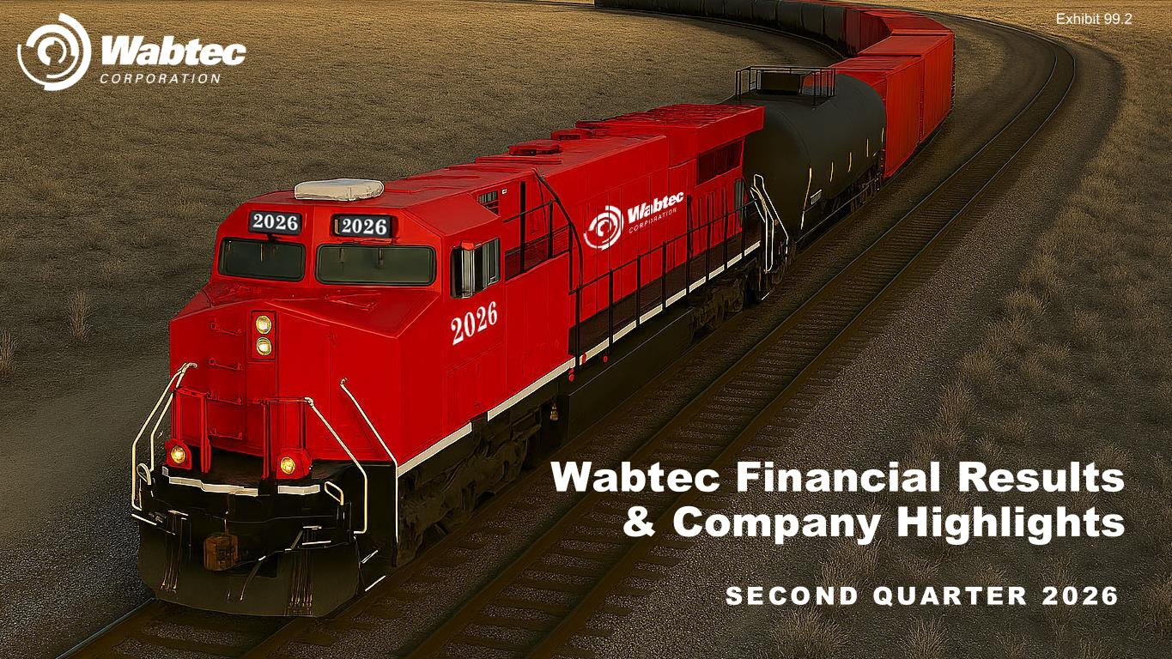

SECOND QUARTER 2026 Wabtec Financial Results & Company Highlights Exhibit 99.2

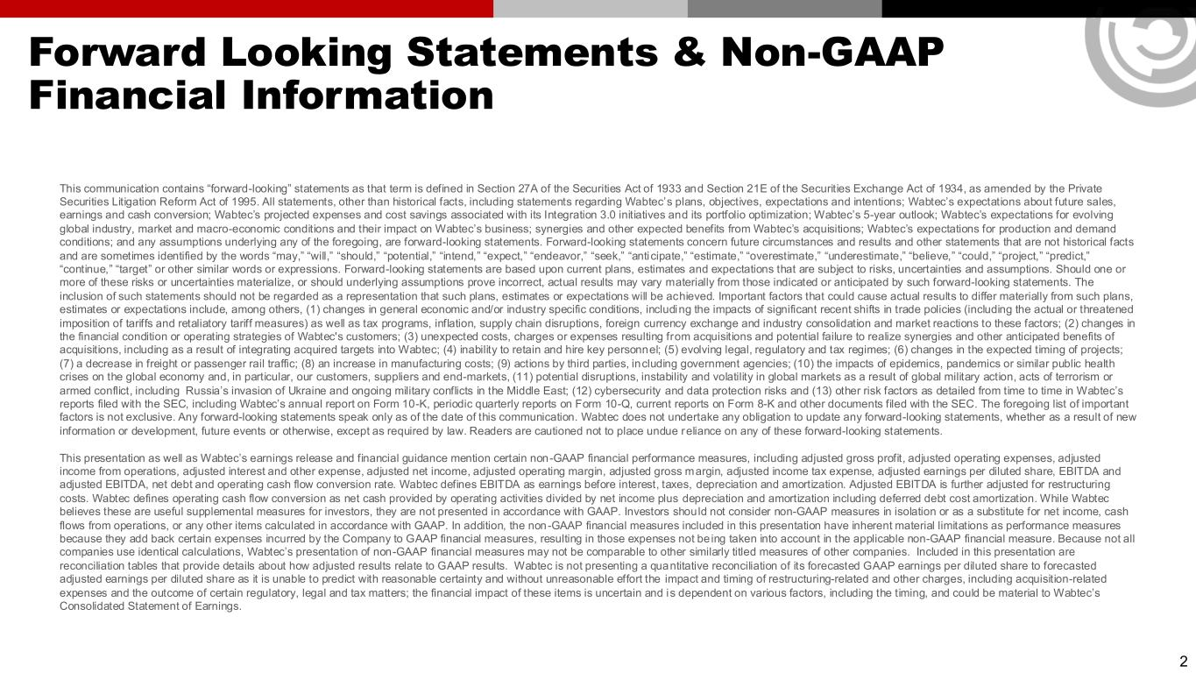
Forward Looking Statements & Non-GAAP Financial Information This communication contains “forward-looking” statements as that term is defined in Section 27A of the Securities Act of 1933 and Section 21E of the Securities Exchange Act of 1934, as amended by the Private Securities Litigation Reform Act of 1995. All statements, other than historical facts, including statements regarding Wabtec’s plans, objectives, expectations and intentions; Wabtec’s expectations about future sales, earnings and cash conversion; Wabtec’s projected expenses and cost savings associated with its Integration 3.0 initiatives and its portfolio optimization; Wabtec’s 5-year outlook; Wabtec’s expectations for evolving global industry, market and macro-economic conditions and their impact on Wabtec’s business; synergies and other expected benefits from Wabtec’s acquisitions; Wabtec’s expectations for production and demand conditions; and any assumptions underlying any of the foregoing, are forward-looking statements. Forward-looking statements concern future circumstances and results and other statements that are not historical facts and are sometimes identified by the words “may,” “will,” “should,” “potential,” “intend,” “expect,” “endeavor,” “seek,” “anticipate,” “estimate,” “overestimate,” “underestimate,” “believe,” “could,” “project,” “predict,” “continue,” “target” or other similar words or expressions. Forward-looking statements are based upon current plans, estimates and expectations that are subject to risks, uncertainties and assumptions. Should one or more of these risks or uncertainties materialize, or should underlying assumptions prove incorrect, actual results may vary materially from those indicated or anticipated by such forward-looking statements. The inclusion of such statements should not be regarded as a representation that such plans, estimates or expectations will be achieved. Important factors that could cause actual results to differ materially from such plans, estimates or expectations include, among others, (1) changes in general economic and/or industry specific conditions, including the impacts of significant recent shifts in trade policies (including the actual or threatened imposition of tariffs and retaliatory tariff measures) as well as tax programs, inflation, supply chain disruptions, foreign currency exchange and industry consolidation and market reactions to these factors; (2) changes in the financial condition or operating strategies of Wabtec's customers; (3) unexpected costs, charges or expenses resulting from acquisitions and potential failure to realize synergies and other anticipated benefits of acquisitions, including as a result of integrating acquired targets into Wabtec; (4) inability to retain and hire key personnel; (5) evolving legal, regulatory and tax regimes; (6) changes in the expected timing of projects; (7) a decrease in freight or passenger rail traffic; (8) an increase in manufacturing costs; (9) actions by third parties, including government agencies; (10) the impacts of epidemics, pandemics or similar public health crises on the global economy and, in particular, our customers, suppliers and end-markets, (11) potential disruptions, instability and volatility in global markets as a result of global military action, acts of terrorism or armed conflict, including Russia’s invasion of Ukraine and ongoing military conflicts in the Middle East; (12) cybersecurity and data protection risks and (13) other risk factors as detailed from time to time in Wabtec’s reports filed with the SEC, including Wabtec’s annual report on Form 10-K, periodic quarterly reports on Form 10-Q, current reports on Form 8-K and other documents filed with the SEC. The foregoing list of important factors is not exclusive. Any forward-looking statements speak only as of the date of this communication. Wabtec does not undertake any obligation to update any forward-looking statements, whether as a result of new information or development, future events or otherwise, except as required by law. Readers are cautioned not to place undue reliance on any of these forward-looking statements. This presentation as well as Wabtec’s earnings release and financial guidance mention certain non -GAAP financial performance measures, including adjusted gross profit, adjusted operating expenses, adjusted income from operations, adjusted interest and other expense, adjusted net income, adjusted operating margin, adjusted gross margin, adjusted income tax expense, adjusted earnings per diluted share, EBITDA and adjusted EBITDA, net debt and operating cash flow conversion rate. Wabtec defines EBITDA as earnings before interest, taxes, depreciation and amortization. Adjusted EBITDA is further adjusted for restructuring costs. Wabtec defines operating cash flow conversion as net cash provided by operating activities divided by net income plus depreciation and amortization including deferred debt cost amortization. While Wabtec believes these are useful supplemental measures for investors, they are not presented in accordance with GAAP. Investors should not consider non-GAAP measures in isolation or as a substitute for net income, cash flows from operations, or any other items calculated in accordance with GAAP. In addition, the non-GAAP financial measures included in this presentation have inherent material limitations as performance measures because they add back certain expenses incurred by the Company to GAAP financial measures, resulting in those expenses not be ing taken into account in the applicable non-GAAP financial measure. Because not all companies use identical calculations, Wabtec’s presentation of non-GAAP financial measures may not be comparable to other similarly titled measures of other companies. Included in this presentation are reconciliation tables that provide details about how adjusted results relate to GAAP results. Wabtec is not presenting a quantitative reconciliation of its forecasted GAAP earnings per diluted share to forecasted adjusted earnings per diluted share as it is unable to predict with reasonable certainty and without unreasonable effort the impact and timing of restructuring-related and other charges, including acquisition-related expenses and the outcome of certain regulatory, legal and tax matters; the financial impact of these items is uncertain and is dependent on various factors, including the timing, and could be material to Wabtec’s Consolidated Statement of Earnings. 2


3 RAFAEL SANTANA Chairman & Chief Executive Officer JOHN OLIN Executive Vice President & Chief Financial Officer KYRA YATES Vice President, Investor Relations Today’s Participants

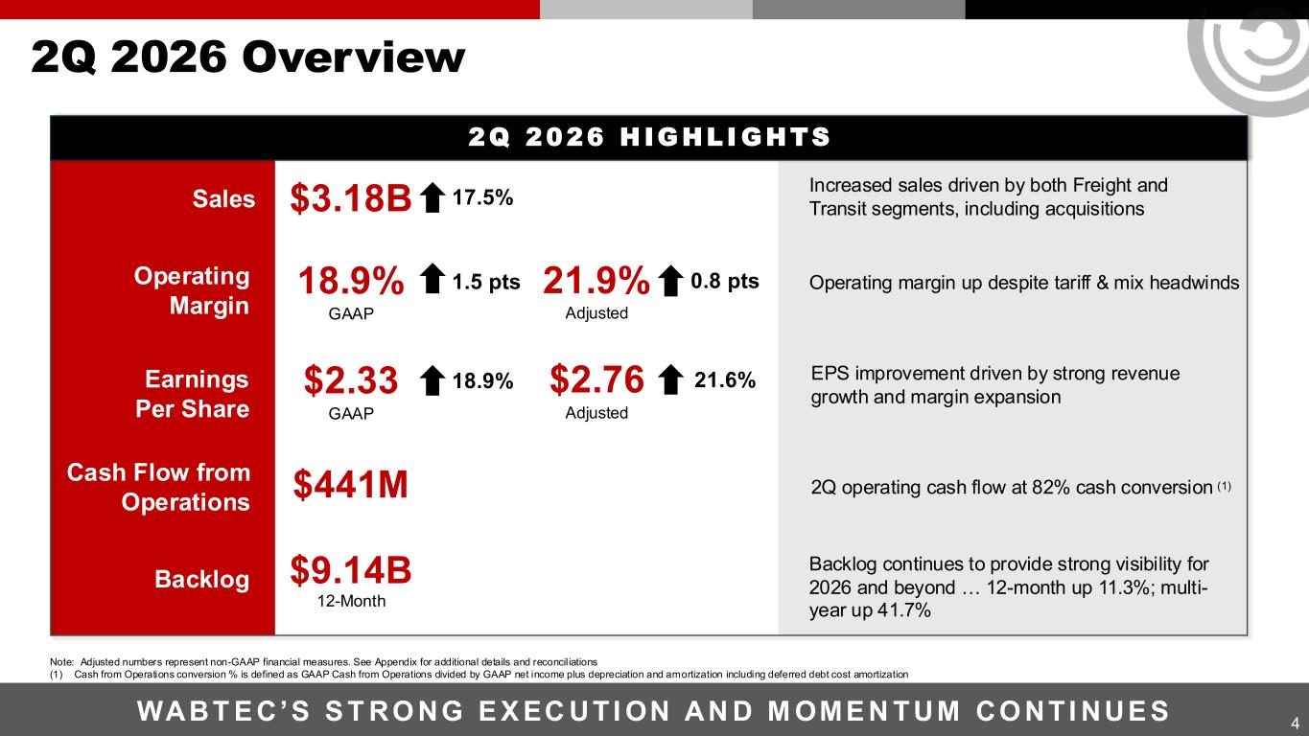
4 2Q 2026 Overview WABT E C’S S T RO NG E X EC UTI ON AN D M OME N TUM CO NTI NUE S Sales Increased sales driven by both Freight and Transit segments, including acquisitions Operating margin up despite tariff & mix headwinds EPS improvement driven by strong revenue growth and margin expansion 2Q operating cash flow at 82% cash conversion (1) Backlog continues to provide strong visibility for 2026 and beyond … 12-month up 11.3%; multi- year up 41.7% Cash Flow from Operations $441M Backlog $9.14B 12-Month Operating Margin 18.9% GAAP 1.5 pts 21.9% Adjusted 0.8 pts Earnings Per Share $2.33 GAAP 18.9% $2.76 Adjusted 21.6% $3.18B 17.5% 2Q 2026 H IGHLI GHTS Note: Adjusted numbers represent non-GAAP financial measures. See Appendix for additional details and reconciliations (1) Cash from Operations conversion % is defined as GAAP Cash from Operations divided by GAAP net income plus depreciation and amortization including deferred debt cost amortization

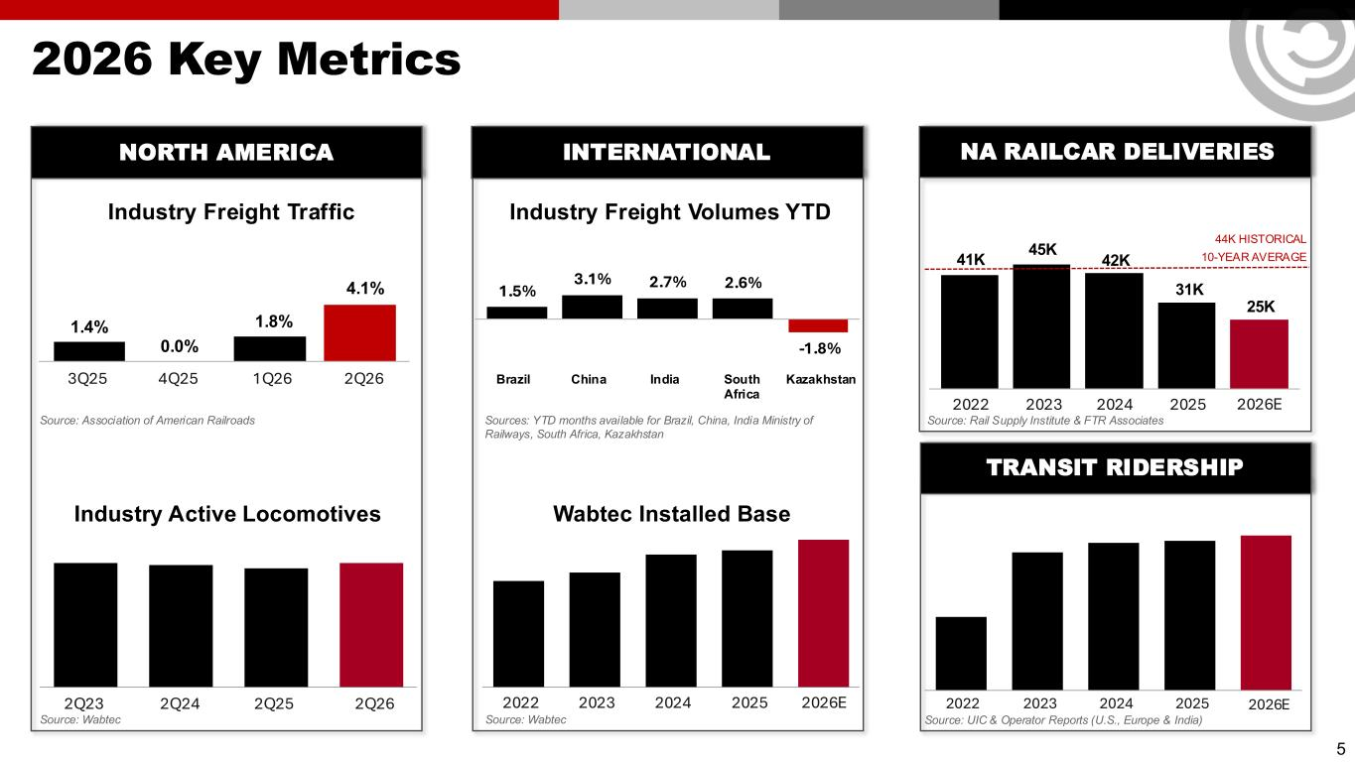
1.4% 0.0% 1.8% 4.1% 5 2026 Key Metrics 3Q25 4Q25 1Q26 2Q26 Industry Active Locomotives 2Q23 2Q24 2Q25 2Q26 Source: Association of American Railroads Source: Wabtec Industry Freight Traffic Source: UIC & Operator Reports (U.S., Europe & India) 2022 2023 2024 2025 Wabtec Installed Base 2022 2023 2024 2025 Industry Freight Volumes YTD Sources: YTD months available for Brazil, China, India Ministry of Railways, South Africa, Kazakhstan Brazil China India South Africa Kazakhstan Source: Wabtec TRANSIT RIDERSHIP NORTH AMERICA INTERNATIONAL NA RAILCAR DELIVERIES Source: Rail Supply Institute & FTR Associates 2022 2023 2024 2025 2026E 41K 45K 42K 31K 44K HISTORICAL 10-YEAR AVERAGE 25K 2026E 2026E 1.5% 3.1% 2.7% 2.6% -1.8%

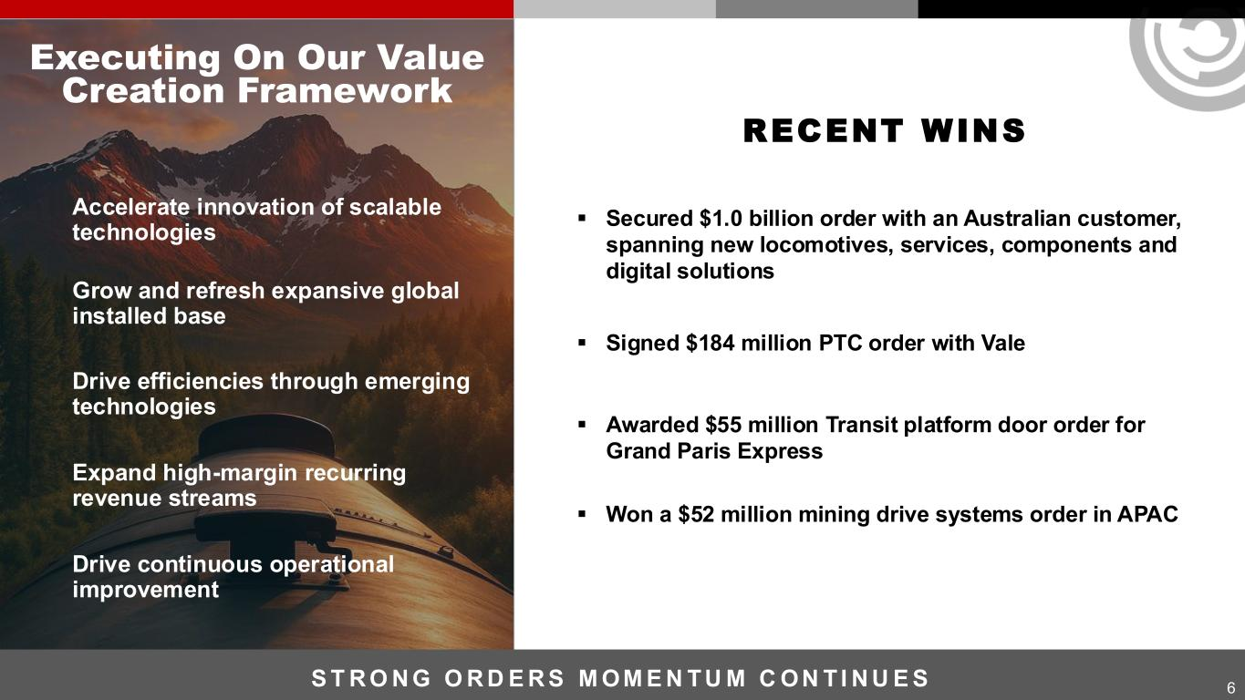
▪ Secured $1.0 billion order with an Australian customer, spanning new locomotives, services, components and digital solutions ▪ Signed $184 million PTC order with Vale ▪ Awarded $55 million Transit platform door order for Grand Paris Express ▪ Won a $52 million mining drive systems order in APAC 6 RECENT WINS Accelerate innovation of scalable technologies Grow and refresh expansive global installed base Drive efficiencies through emerging technologies Expand high-margin recurring revenue streams Drive continuous operational improvement Executing On Our Value Creation Framework S T R O N G O R D E R S M OM E N TU M C ON TI N U E S

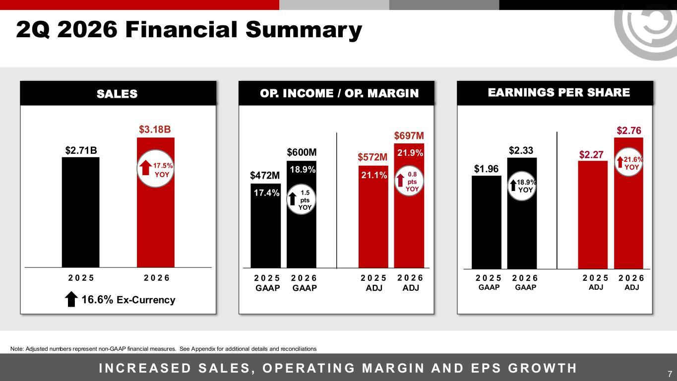
$1.96 $2.33 $2.27 $2.76 7 2Q 2026 Financial Summary I N C R E A S E D S A L E S , O P E R AT IN G M A R GI N A N D E P S G R O W TH Note: Adjusted numbers represent non-GAAP financial measures. See Appendix for additional details and reconciliations 2 0 2 5 GAAP 2 0 2 6 GAAP 2 0 2 5 ADJ 2 0 2 6 ADJ $472M 17.4% 18.9% $572M 21.1% $697M 21.9%$600M 2 0 2 5 2 0 2 6 2 0 2 5 GAAP 2 0 2 6 GAAP 2 0 2 5 ADJ 2 0 2 6 ADJ $3.18B $2.71B 17.5% YOY 18.9% YOY 21.6% YOY 16.6% Ex-Currency OP. INCOME / OP. MARGIN EARNINGS PER SHARESALES 1.5 pts YOY 0.8 pts YOY

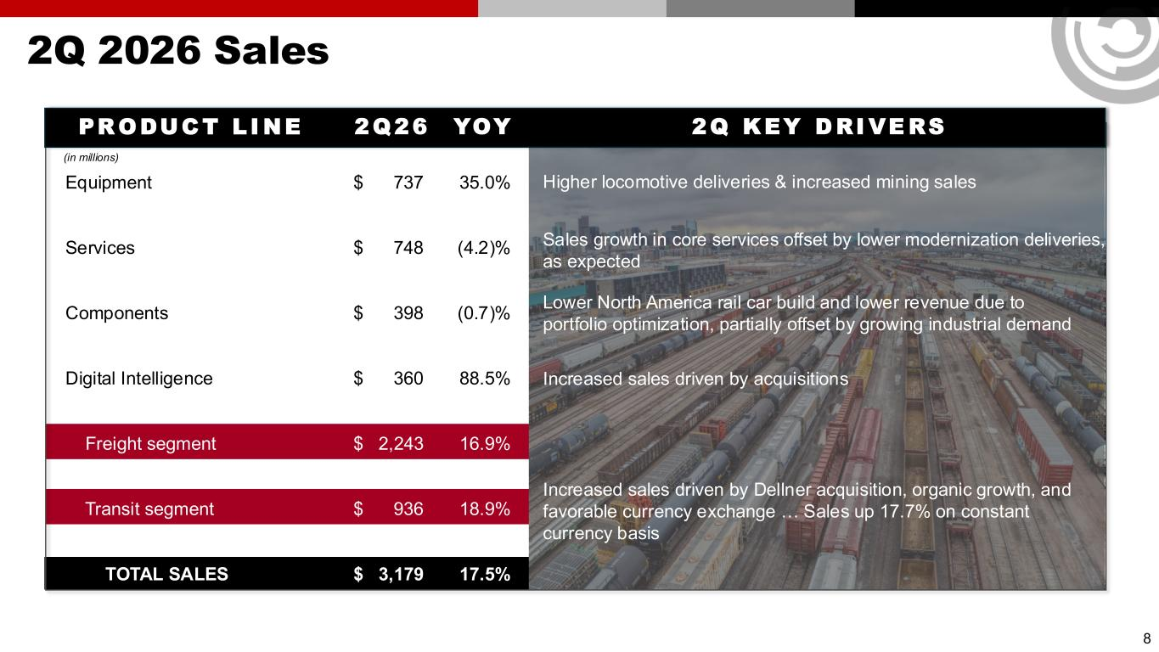
2Q 2026 Sales 8 PR ODUC T L I NE 2Q26 YOY 2Q KEY D RI VE RS (in millions) Equipment $ 737 35.0% Services $ 748 (4.2)% Components $ 398 (0.7)% Digital Intelligence $ 360 88.5% Freight segment $ 2,243 16.9% Transit segment $ 936 18.9% TOTAL SALES $ 3,179 17.5% Sales growth in core services offset by lower modernization deliveries, as expected Higher locomotive deliveries & increased mining sales Lower North America rail car build and lower revenue due to portfolio optimization, partially offset by growing industrial demand Increased sales driven by acquisitions Increased sales driven by Dellner acquisition, organic growth, and favorable currency exchange … Sales up 17.7% on constant currency basis

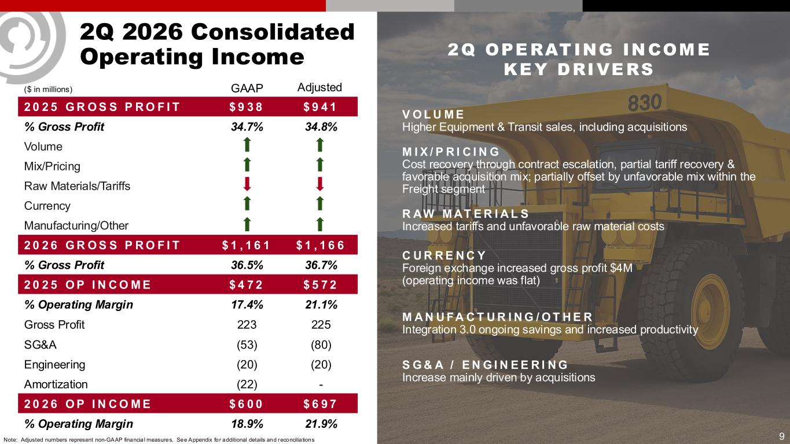
9 2Q 2026 Consolidated Operating Income ($ in millions) 2 0 2 5 G R O S S P R O F I T $ 9 3 8 $ 9 4 1 % Gross Profit 34.7% 34.8% Volume Mix/Pricing Raw Materials/Tariffs Currency Manufacturing/Other 2 0 2 6 G R O S S P R O F I T $ 1 , 1 6 1 $ 1 , 1 6 6 % Gross Profit 36.5% 36.7% 2 0 2 5 O P I N C O M E $ 4 7 2 $ 5 7 2 % Operating Margin 17.4% 21.1% Gross Profit 223 225 SG&A (53) (80) Engineering (20) (20) Amortization (22) - 2 0 2 6 O P I N C O M E $ 6 0 0 $ 6 9 7 % Operating Margin 18.9% 21.9% GAAP Adjusted Note: Adjusted numbers represent non-GAAP financia l measures. See Appendix for additional details and reconcilia tions V O L U M E Higher Equipment & Transit sales, including acquisitions M I X / P R I C I N G Cost recovery through contract escalation, partial tariff recovery & favorable acquisition mix; partially offset by unfavorable mix within the Freight segment R AW M AT E R I A L S Increased tariffs and unfavorable raw material costs C U R R E N C Y Foreign exchange increased gross profit $4M (operating income was flat) M A N U FA C T U R I N G / O T H E R Integration 3.0 ongoing savings and increased productivity S G & A / E N G I N E E R I N G Increase mainly driven by acquisitions 2Q OPERATING INCOME KEY DRIVERS

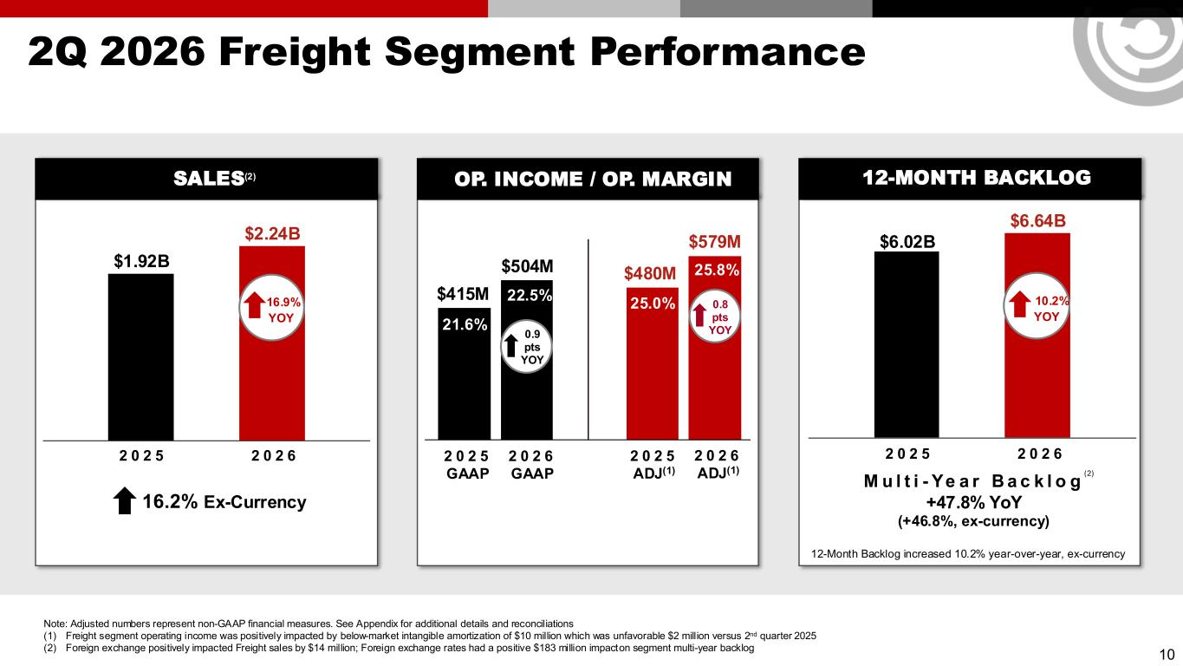
10 2Q 2026 Freight Segment Performance 2 0 2 5 GAAP 2 0 2 6 GAAP 2 0 2 5 ADJ(1) 2 0 2 6 ADJ(1) $415M 22.5% 21.6% $480M 25.0% $579M 25.8%$504M 2 0 2 5 2 0 2 6 $2.24B $1.92B 16.9% YOY 2 0 2 5 2 0 2 6 $6.64B $6.02B 10.2% YOY Note: Adjusted numbers represent non-GAAP financial measures. See Appendix for additional details and reconciliations (1) Freight segment operating income was positively impacted by below-market intangible amortization of $10 million which was unfavorable $2 million versus 2nd quarter 2025 (2) Foreign exchange positively impacted Freight sales by $14 million; Foreign exchange rates had a positive $183 million impact on segment multi-year backlog 12-Month Backlog increased 10.2% year-over-year, ex-currency M u l t i - Ye a r B a c k l o g +47.8% YoY (+46.8%, ex-currency) 16.2% Ex-Currency OP. INCOME / OP. MARGIN 12-MONTH BACKLOGSALES(2) 0.9 pts YOY 0.8 pts YOY (2)

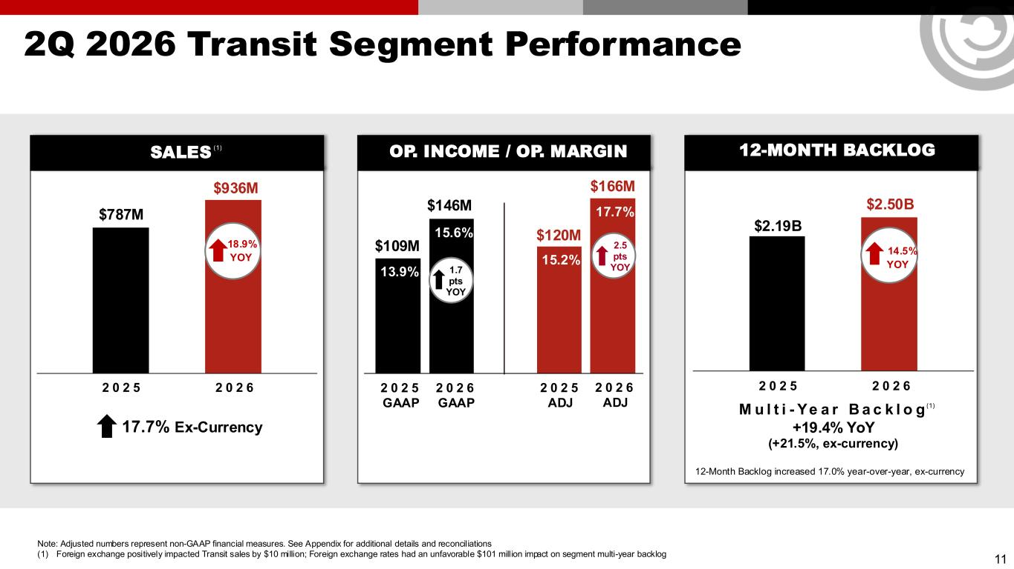
11 2Q 2026 Transit Segment Performance 2 0 2 5 GAAP 2 0 2 6 GAAP 2 0 2 5 ADJ 2 0 2 6 ADJ 2 0 2 5 2 0 2 6 2 0 2 5 2 0 2 6 12-Month Backlog increased 17.0% year-over-year, ex-currency M u l t i - Ye a r B a c k l o g +19.4% YoY (+21.5%, ex-currency) 17.7% Ex-Currency OP. INCOME / OP. MARGIN 12-MONTH BACKLOGSALES $109M 13.9% 15.6% $120M 15.2% $166M 17.7%$146M $936M $787M 18.9% YOY $2.50B $2.19B 14.5% YOY Note: Adjusted numbers represent non-GAAP financial measures. See Appendix for additional details and reconciliations (1) Foreign exchange positively impacted Transit sales by $10 million; Foreign exchange rates had an unfavorable $101 million impact on segment multi-year backlog 1.7 pts YOY 2.5 pts YOY (1) (1)

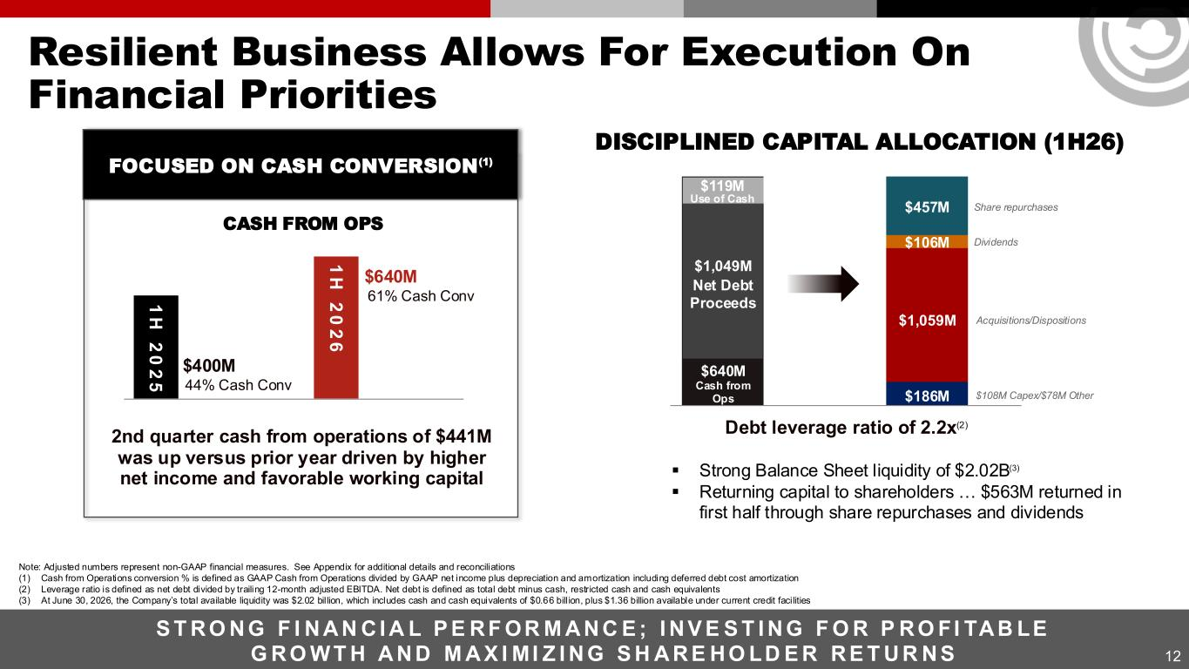
12 Resilient Business Allows For Execution On Financial Priorities S T R O N G F I N A N C I A L P E R F OR M A N C E ; I N V E S T I N G F O R P R O FI TA B LE G R O W T H A N D M A X I MI Z I N G S H A R E H O LD E R R E T U R N S 2nd quarter cash from operations of $441M was up versus prior year driven by higher net income and favorable working capital 44% Cash Conv $400M $640M 1 H 2 0 2 6 61% Cash Conv1 H 2 0 2 5 Debt leverage ratio of 2.2x(2) FOCUSED ON CASH CONVERSION(1) DISCIPLINED CAPITAL ALLOCATION (1H26) $640M Cash from Ops $1,059M $108M Capex/$78M Other Dividends$106M $186M $457M $1,049M Net Debt Proceeds Acquisitions/Dispositions Share repurchases ▪ Strong Balance Sheet liquidity of $2.02B(3) ▪ Returning capital to shareholders … $563M returned in first half through share repurchases and dividends Note: Adjusted numbers represent non-GAAP financial measures. See Appendix for additional details and reconciliations (1) Cash from Operations conversion % is defined as GAAP Cash from Operations divided by GAAP net income plus depreciation and amortization including deferred debt cost amortization (2) Leverage ratio is defined as net debt divided by trailing 12-month adjusted EBITDA. Net debt is defined as total debt minus cash, restricted cash and cash equivalents (3) At June 30, 2026, the Company’s total available liquidity was $2.02 billion, which includes cash and cash equivalents of $0.66 bill ion, plus $1.36 billion available under current credit facilities CASH FROM OPS $119M Use of Cash

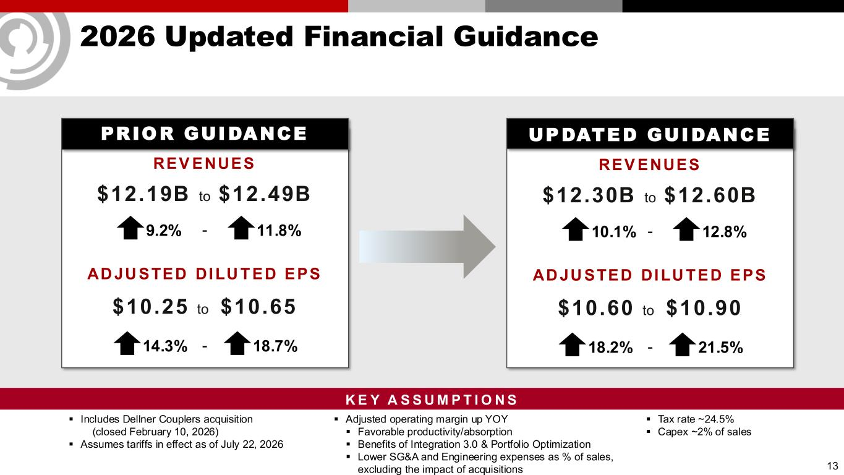
2026 Updated Financial Guidance PRIOR GUIDANCE REV ENUES $12.19B to $12.49B AD JU STED DILU TED EPS $10.25 to $10.65 9.2% 11.8% 14.3% 18.7%- - 13 ▪ Includes Dellner Couplers acquisition (closed February 10, 2026) ▪ Assumes tariffs in effect as of July 22, 2026 UPDATED GUIDANCE REV ENUES $12.30B to $12.60B AD JU STED DILU TED EPS $10.60 to $10.90 10.1% 12.8% 18.2% 21.5%- - ▪ Tax rate ~24.5% ▪ Capex ~2% of sales ▪ Adjusted operating margin up YOY ▪ Favorable productivity/absorption ▪ Benefits of Integration 3.0 & Portfolio Optimization ▪ Lower SG&A and Engineering expenses as % of sales, excluding the impact of acquisitions K E Y A S S U M P T I O N S

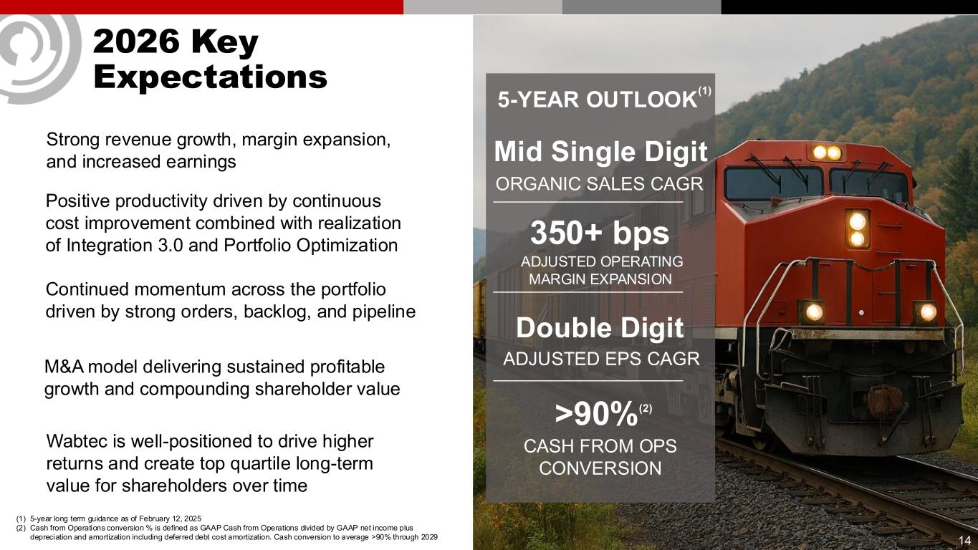
14 2026 Key Expectations Continued momentum across the portfolio driven by strong orders, backlog, and pipeline Positive productivity driven by continuous cost improvement combined with realization of Integration 3.0 and Portfolio Optimization Wabtec is well-positioned to drive higher returns and create top quartile long-term value for shareholders over time Strong revenue growth, margin expansion, and increased earnings 5-YEAR OUTLOOK (1) Mid Single Digit ORGANIC SALES CAGR Double Digit ADJUSTED EPS CAGR >90%(2) CASH FROM OPS CONVERSION 350+ bps ADJUSTED OPERATING MARGIN EXPANSION (1) 5-year long term guidance as of February 12, 2025 (2) Cash from Operations conversion % is defined as GAAP Cash from Operations divided by GAAP net income plus depreciation and amortization including deferred debt cost amortization. Cash conversion to average >90% through 2029 M&A model delivering sustained profitable growth and compounding shareholder value

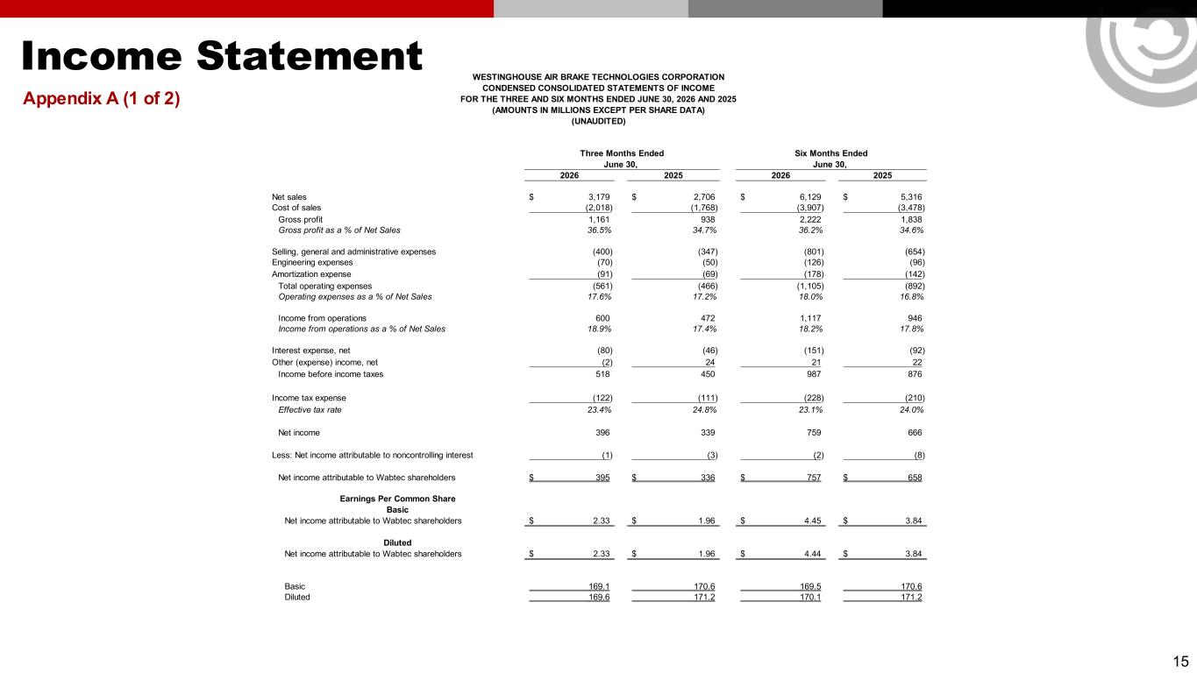
Income Statement Appendix A (1 of 2) 15 2026 2025 2026 2025 Net sales 3,179$ 2,706$ 6,129$ 5,316$ Cost of sales (2,018) (1,768) (3,907) (3,478) Gross profit 1,161 938 2,222 1,838 Gross profit as a % of Net Sales 36.5% 34.7% 36.2% 34.6% Selling, general and administrative expenses (400) (347) (801) (654) Engineering expenses (70) (50) (126) (96) Amortization expense (91) (69) (178) (142) Total operating expenses (561) (466) (1,105) (892) Operating expenses as a % of Net Sales 17.6% 17.2% 18.0% 16.8% Income from operations 600 472 1,117 946 Income from operations as a % of Net Sales 18.9% 17.4% 18.2% 17.8% Interest expense, net (80) (46) (151) (92) Other (expense) income, net (2) 24 21 22 Income before income taxes 518 450 987 876 Income tax expense (122) (111) (228) (210) Effective tax rate 23.4% 24.8% 23.1% 24.0% Net income 396 339 759 666 Less: Net income attributable to noncontrolling interest (1) (3) (2) (8) Net income attributable to Wabtec shareholders 395$ 336$ 757$ 658$ Earnings Per Common Share Basic Net income attributable to Wabtec shareholders 2.33$ 1.96$ 4.45$ 3.84$ Diluted Net income attributable to Wabtec shareholders 2.33$ 1.96$ 4.44$ 3.84$ Basic 169.1 170.6 169.5 170.6 Diluted 169.6 171.2 170.1 171.2 June 30, June 30, Three Months Ended Six Months Ended WESTINGHOUSE AIR BRAKE TECHNOLOGIES CORPORATION CONDENSED CONSOLIDATED STATEMENTS OF INCOME FOR THE THREE AND SIX MONTHS ENDED JUNE 30, 2026 AND 2025 (AMOUNTS IN MILLIONS EXCEPT PER SHARE DATA) (UNAUDITED)

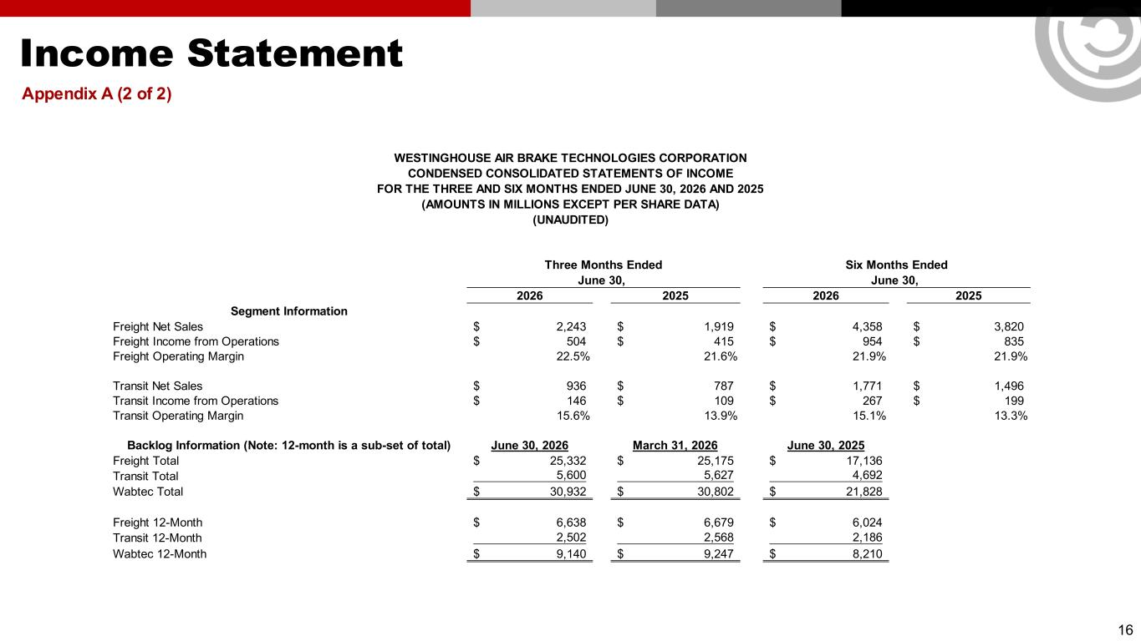
Income Statement Appendix A (2 of 2) 16 2026 2025 2026 2025 Segment Information Freight Net Sales 2,243$ 1,919$ 4,358$ 3,820$ Freight Income from Operations 504$ 415$ 954$ 835$ Freight Operating Margin 22.5% 21.6% 21.9% 21.9% Transit Net Sales 936$ 787$ 1,771$ 1,496$ Transit Income from Operations 146$ 109$ 267$ 199$ Transit Operating Margin 15.6% 13.9% 15.1% 13.3% Backlog Information (Note: 12-month is a sub-set of total) June 30, 2026 March 31, 2026 June 30, 2025 Freight Total 25,332$ 25,175$ 17,136$ Transit Total 5,600 5,627 4,692 Wabtec Total 30,932$ 30,802$ 21,828$ Freight 12-Month 6,638$ 6,679$ 6,024$ Transit 12-Month 2,502 2,568 2,186 Wabtec 12-Month 9,140$ 9,247$ 8,210$ June 30, June 30, Three Months Ended Six Months Ended WESTINGHOUSE AIR BRAKE TECHNOLOGIES CORPORATION CONDENSED CONSOLIDATED STATEMENTS OF INCOME FOR THE THREE AND SIX MONTHS ENDED JUNE 30, 2026 AND 2025 (AMOUNTS IN MILLIONS EXCEPT PER SHARE DATA) (UNAUDITED)

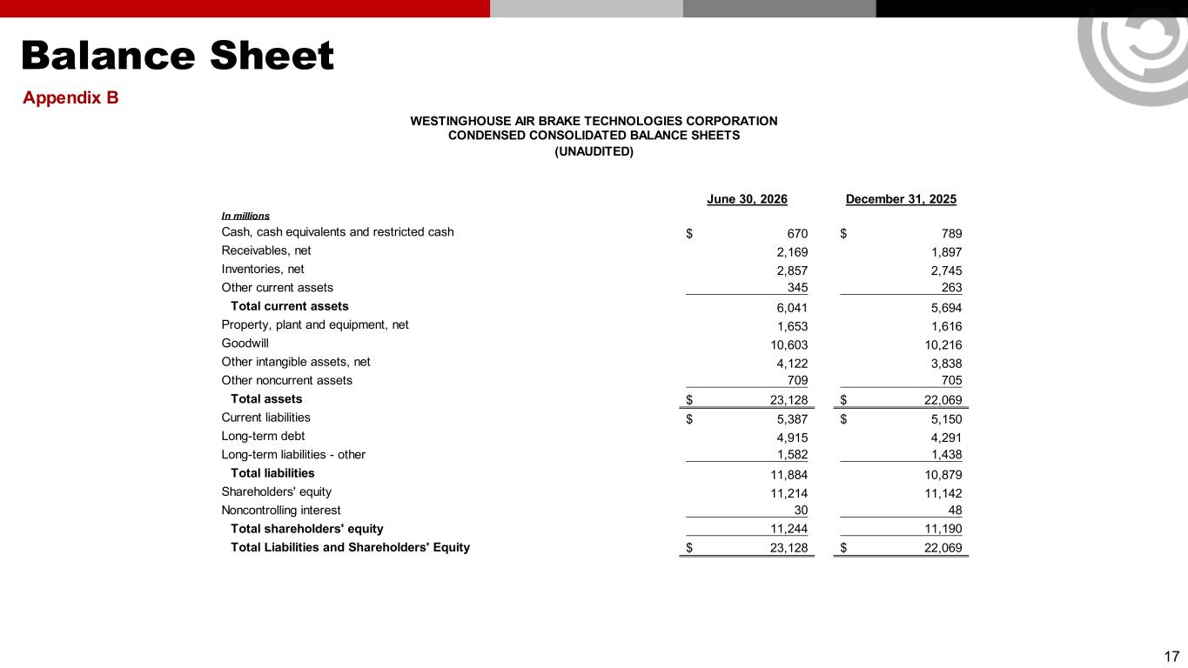
Balance Sheet Appendix B 17 June 30, 2026 December 31, 2025 In millions Cash, cash equivalents and restricted cash 670$ 789$ Receivables, net 2,169 1,897 Inventories, net 2,857 2,745 Other current assets 345 263 Total current assets 6,041 5,694 Property, plant and equipment, net 1,653 1,616 Goodwill 10,603 10,216 Other intangible assets, net 4,122 3,838 Other noncurrent assets 709 705 Total assets 23,128$ 22,069$ Current liabilities 5,387$ 5,150$ Long-term debt 4,915 4,291 Long-term liabilities - other 1,582 1,438 Total liabilities 11,884 10,879 Shareholders' equity 11,214 11,142 Noncontrolling interest 30 48 Total shareholders' equity 11,244 11,190 Total Liabilities and Shareholders' Equity 23,128$ 22,069$ WESTINGHOUSE AIR BRAKE TECHNOLOGIES CORPORATION CONDENSED CONSOLIDATED BALANCE SHEETS (UNAUDITED)

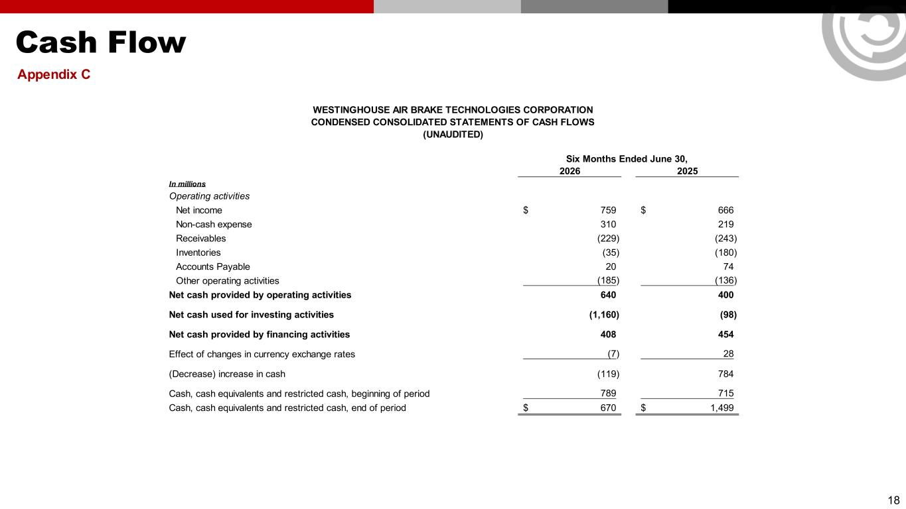
Cash Flow Appendix C 18 2026 2025 In millions Operating activities Net income 759$ 666$ Non-cash expense 310 219 Receivables (229) (243) Inventories (35) (180) Accounts Payable 20 74 Other operating activities (185) (136) Net cash provided by operating activities 640 400 Net cash used for investing activities (1,160) (98) Net cash provided by financing activities 408 454 Effect of changes in currency exchange rates (7) 28 (Decrease) increase in cash (119) 784 Cash, cash equivalents and restricted cash, beginning of period 789 715 Cash, cash equivalents and restricted cash, end of period 670$ 1,499$ WESTINGHOUSE AIR BRAKE TECHNOLOGIES CORPORATION CONDENSED CONSOLIDATED STATEMENTS OF CASH FLOWS (UNAUDITED) Six Months Ended June 30,

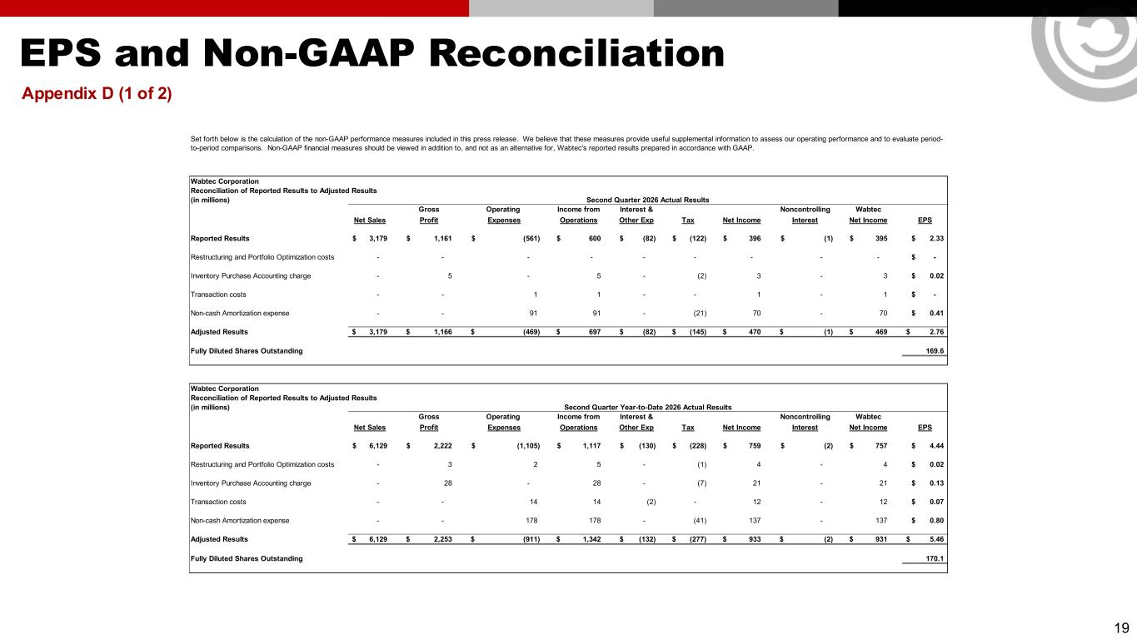
EPS and Non-GAAP Reconciliation Appendix D (1 of 2) 19 Wabtec Corporation Reconciliation of Reported Results to Adjusted Results (in millions) Gross Operating Income from Interest & Noncontrolling Wabtec Net Sales Profit Expenses Operations Other Exp Tax Net Income Interest Net Income EPS Reported Results 3,179$ 1,161$ (561)$ 600$ (82)$ (122)$ 396$ (1)$ 395$ 2.33$ Restructuring and Portfolio Optimization costs - - - - - - - - - -$ Inventory Purchase Accounting charge - 5 - 5 - (2) 3 - 3 0.02$ Transaction costs - - 1 1 - - 1 - 1 -$ Non-cash Amortization expense - - 91 91 - (21) 70 - 70 0.41$ Adjusted Results 3,179$ 1,166$ (469)$ 697$ (82)$ (145)$ 470$ (1)$ 469$ 2.76$ Fully Diluted Shares Outstanding 169.6 Wabtec Corporation Reconciliation of Reported Results to Adjusted Results (in millions) Gross Operating Income from Interest & Noncontrolling Wabtec Net Sales Profit Expenses Operations Other Exp Tax Net Income Interest Net Income EPS Reported Results 6,129$ 2,222$ (1,105)$ 1,117$ (130)$ (228)$ 759$ (2)$ 757$ 4.44$ Restructuring and Portfolio Optimization costs - 3 2 5 - (1) 4 - 4 0.02$ Inventory Purchase Accounting charge - 28 - 28 - (7) 21 - 21 0.13$ Transaction costs - - 14 14 (2) - 12 - 12 0.07$ Non-cash Amortization expense - - 178 178 - (41) 137 - 137 0.80$ Adjusted Results 6,129$ 2,253$ (911)$ 1,342$ (132)$ (277)$ 933$ (2)$ 931$ 5.46$ Fully Diluted Shares Outstanding 170.1 Set forth below is the calculation of the non-GAAP performance measures included in this press release. We believe that these measures provide useful supplemental information to assess our operating performance and to evaluate period- to-period comparisons. Non-GAAP financial measures should be viewed in addition to, and not as an alternative for, Wabtec's reported results prepared in accordance with GAAP. Second Quarter 2026 Actual Results Second Quarter Year-to-Date 2026 Actual Results

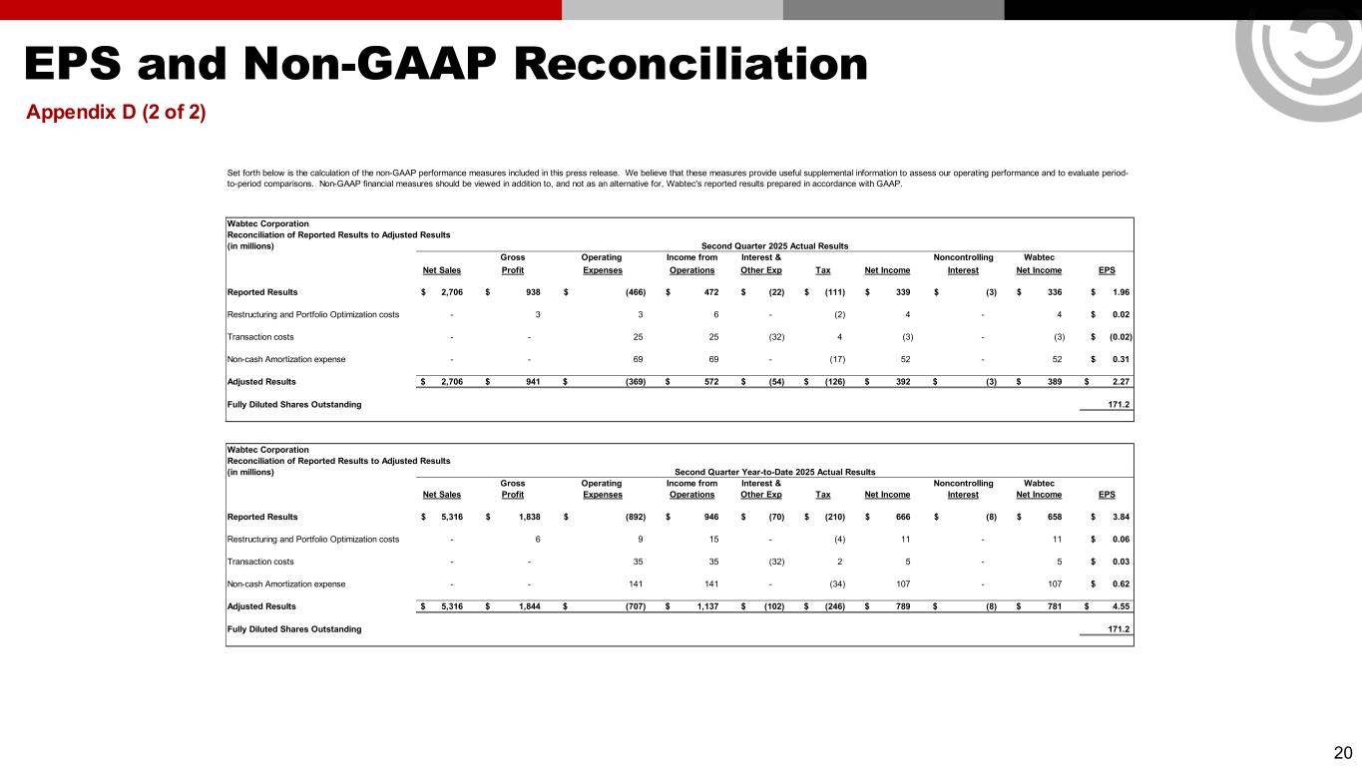
EPS and Non-GAAP Reconciliation Appendix D (2 of 2) 20 Wabtec Corporation Reconciliation of Reported Results to Adjusted Results (in millions) Gross Operating Income from Interest & Noncontrolling Wabtec Net Sales Profit Expenses Operations Other Exp Tax Net Income Interest Net Income EPS Reported Results 2,706$ 938$ (466)$ 472$ (22)$ (111)$ 339$ (3)$ 336$ 1.96$ Restructuring and Portfolio Optimization costs - 3 3 6 - (2) 4 - 4 0.02$ Transaction costs - - 25 25 (32) 4 (3) - (3) (0.02)$ Non-cash Amortization expense - - 69 69 - (17) 52 - 52 0.31$ Adjusted Results 2,706$ 941$ (369)$ 572$ (54)$ (126)$ 392$ (3)$ 389$ 2.27$ Fully Diluted Shares Outstanding 171.2 Wabtec Corporation Reconciliation of Reported Results to Adjusted Results (in millions) Gross Operating Income from Interest & Noncontrolling Wabtec Net Sales Profit Expenses Operations Other Exp Tax Net Income Interest Net Income EPS Reported Results 5,316$ 1,838$ (892)$ 946$ (70)$ (210)$ 666$ (8)$ 658$ 3.84$ Restructuring and Portfolio Optimization costs - 6 9 15 - (4) 11 - 11 0.06$ Transaction costs - - 35 35 (32) 2 5 - 5 0.03$ Non-cash Amortization expense - - 141 141 - (34) 107 - 107 0.62$ Adjusted Results 5,316$ 1,844$ (707)$ 1,137$ (102)$ (246)$ 789$ (8)$ 781$ 4.55$ Fully Diluted Shares Outstanding 171.2 Second Quarter Year-to-Date 2025 Actual Results Set forth below is the calculation of the non-GAAP performance measures included in this press release. We believe that these measures provide useful supplemental information to assess our operating performance and to evaluate period- to-period comparisons. Non-GAAP financial measures should be viewed in addition to, and not as an alternative for, Wabtec's reported results prepared in accordance with GAAP. Second Quarter 2025 Actual Results

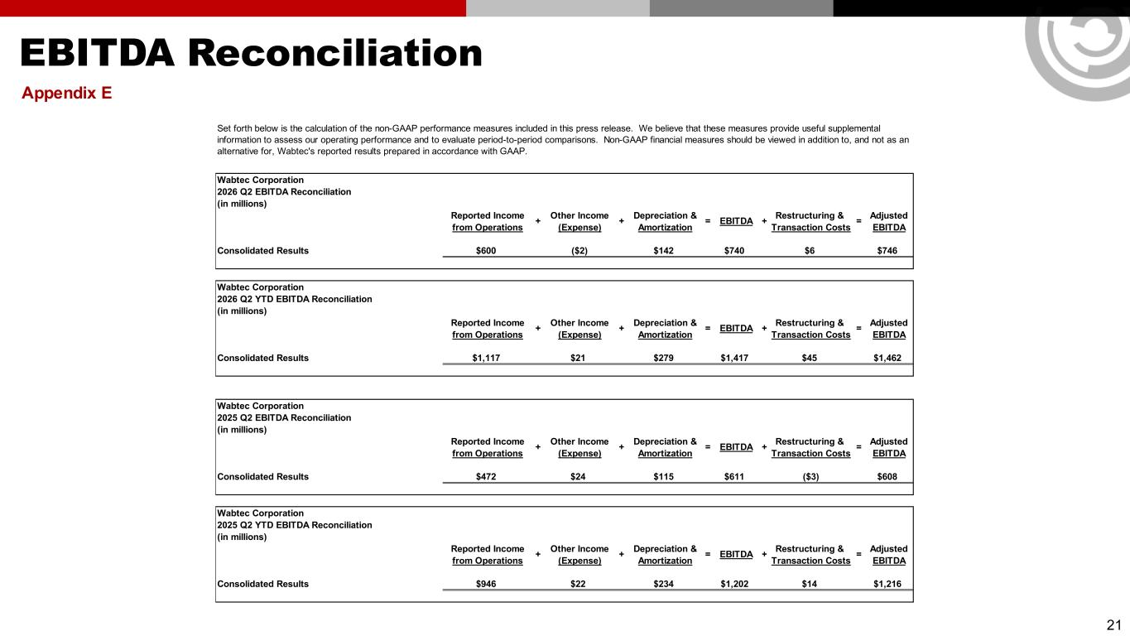
EBITDA Reconciliation Appendix E 21 Wabtec Corporation 2026 Q2 EBITDA Reconciliation (in millions) Reported Income Other Income Depreciation & Restructuring & Adjusted from Operations (Expense) Amortization Transaction Costs EBITDA Consolidated Results $600 ($2) $142 $740 $6 $746 Wabtec Corporation 2026 Q2 YTD EBITDA Reconciliation (in millions) Reported Income Other Income Depreciation & Restructuring & Adjusted from Operations (Expense) Amortization Transaction Costs EBITDA Consolidated Results $1,117 $21 $279 $1,417 $45 $1,462 Wabtec Corporation 2025 Q2 EBITDA Reconciliation (in millions) Reported Income Other Income Depreciation & Restructuring & Adjusted from Operations (Expense) Amortization Transaction Costs EBITDA Consolidated Results $472 $24 $115 $611 ($3) $608 Wabtec Corporation 2025 Q2 YTD EBITDA Reconciliation (in millions) Reported Income Other Income Depreciation & Restructuring & Adjusted from Operations (Expense) Amortization Transaction Costs EBITDA Consolidated Results $946 $22 $234 $1,202 $14 $1,216 = + + = EBITDA + = + + = EBITDA + = Set forth below is the calculation of the non-GAAP performance measures included in this press release. We believe that these measures provide useful supplemental information to assess our operating performance and to evaluate period-to-period comparisons. Non-GAAP financial measures should be viewed in addition to, and not as an alternative for, Wabtec's reported results prepared in accordance with GAAP. + + = EBITDA + = + + = EBITDA +

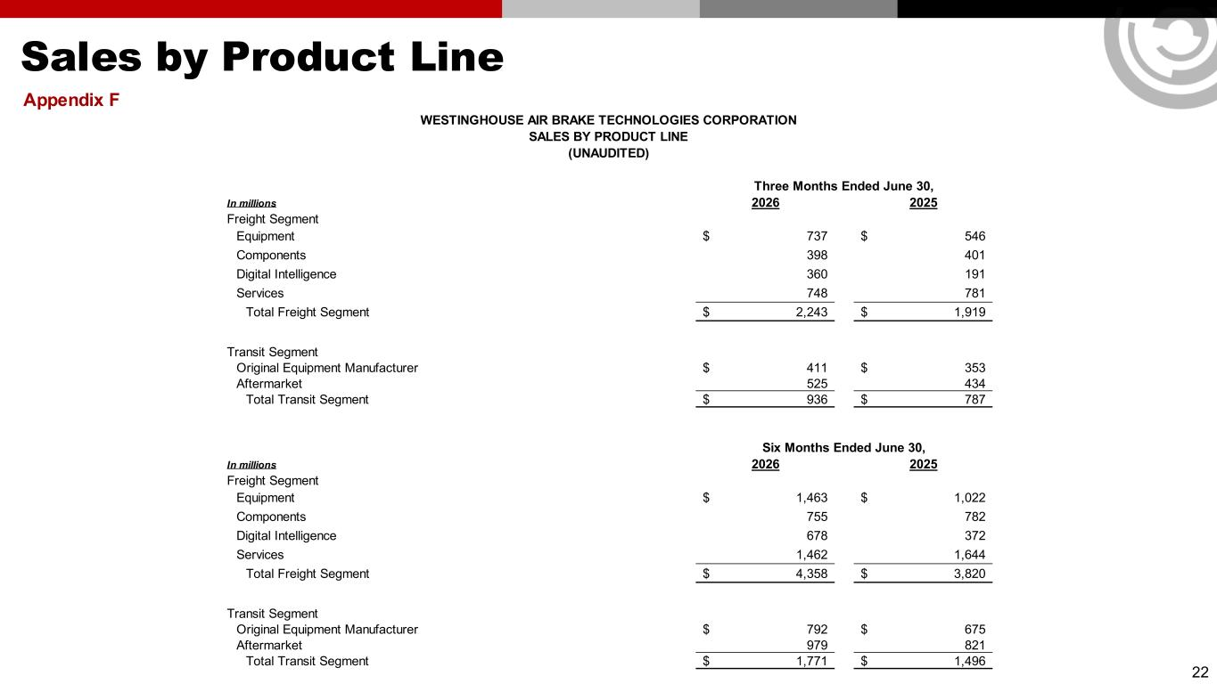
Sales by Product Line Appendix F 22 In millions 2026 2025 Freight Segment Equipment 737$ 546$ Components 398 401 Digital Intelligence 360 191 Services 748 781 Total Freight Segment 2,243$ 1,919$ Transit Segment Original Equipment Manufacturer 411$ 353$ Aftermarket 525 434 Total Transit Segment 936$ 787$ In millions 2026 2025 Freight Segment Equipment 1,463$ 1,022$ Components 755 782 Digital Intelligence 678 372 Services 1,462 1,644 Total Freight Segment 4,358$ 3,820$ Transit Segment Original Equipment Manufacturer 792$ 675$ Aftermarket 979 821 Total Transit Segment 1,771$ 1,496$ Six Months Ended June 30, WESTINGHOUSE AIR BRAKE TECHNOLOGIES CORPORATION SALES BY PRODUCT LINE (UNAUDITED) Three Months Ended June 30,

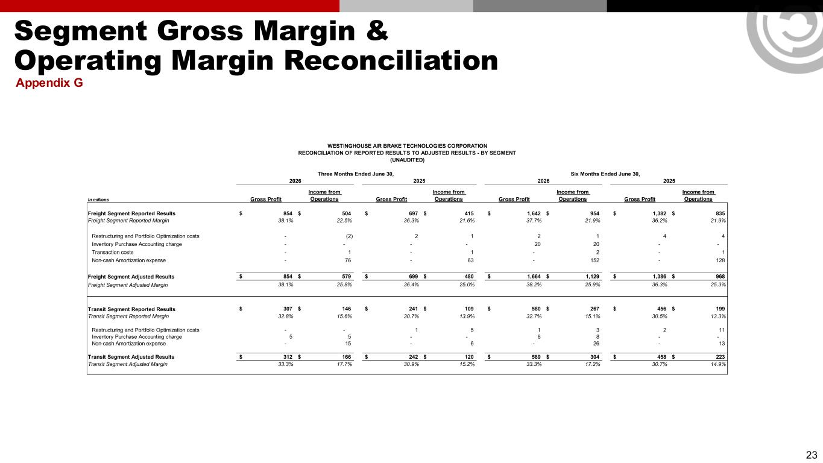
Segment Gross Margin & Operating Margin Reconciliation Appendix G 23 In millions Gross Profit Income from Operations Gross Profit Income from Operations Gross Profit Income from Operations Gross Profit Income from Operations Freight Segment Reported Results 854$ 504$ 697$ 415$ 1,642$ 954$ 1,382$ 835$ Freight Segment Reported Margin 38.1% 22.5% 36.3% 21.6% 37.7% 21.9% 36.2% 21.9% Restructuring and Portfolio Optimization costs - (2) 2 1 2 1 4 4 Inventory Purchase Accounting charge - - - - 20 20 - - Transaction costs - 1 - 1 - 2 - 1 Non-cash Amortization expense - 76 - 63 - 152 - 128 Freight Segment Adjusted Results 854$ 579$ 699$ 480$ 1,664$ 1,129$ 1,386$ 968$ Freight Segment Adjusted Margin 38.1% 25.8% 36.4% 25.0% 38.2% 25.9% 36.3% 25.3% Transit Segment Reported Results 307$ 146$ 241$ 109$ 580$ 267$ 456$ 199$ Transit Segment Reported Margin 32.8% 15.6% 30.7% 13.9% 32.7% 15.1% 30.5% 13.3% Restructuring and Portfolio Optimization costs - - 1 5 1 3 2 11 Inventory Purchase Accounting charge 5 5 - - 8 8 - - Non-cash Amortization expense - 15 - 6 - 26 - 13 Transit Segment Adjusted Results 312$ 166$ 242$ 120$ 589$ 304$ 458$ 223$ Transit Segment Adjusted Margin 33.3% 17.7% 30.9% 15.2% 33.3% 17.2% 30.7% 14.9% 2026 2025 2026 2025 WESTINGHOUSE AIR BRAKE TECHNOLOGIES CORPORATION RECONCILIATION OF REPORTED RESULTS TO ADJUSTED RESULTS - BY SEGMENT (UNAUDITED) Three Months Ended June 30, Six Months Ended June 30,

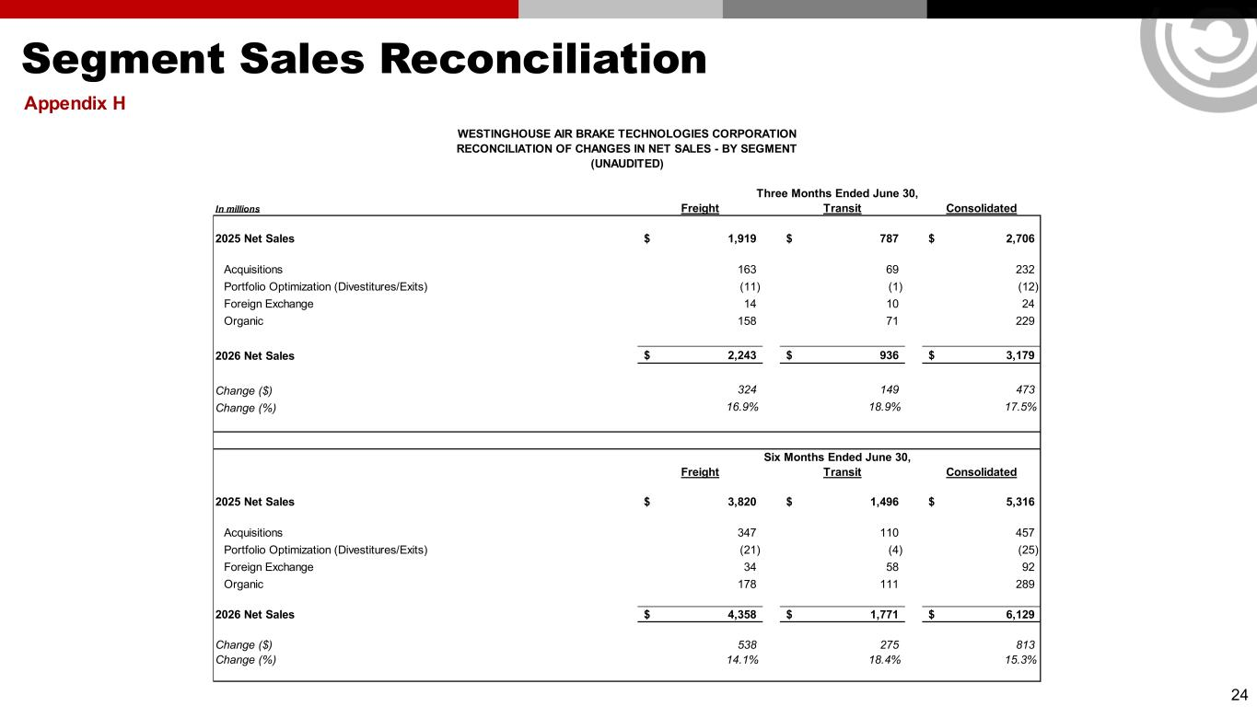
Segment Sales Reconciliation Appendix H 24 In millions Freight Transit Consolidated 2025 Net Sales 1,919$ 787$ 2,706$ Acquisitions 163 69 232 Portfolio Optimization (Divestitures/Exits) (11) (1) (12) Foreign Exchange 14 10 24 Organic 158 71 229 2026 Net Sales 2,243$ 936$ 3,179$ Change ($) 324 149 473 Change (%) 16.9% 18.9% 17.5% Freight Transit Consolidated 2025 Net Sales 3,820$ 1,496$ 5,316$ Acquisitions 347 110 457 Portfolio Optimization (Divestitures/Exits) (21) (4) (25) Foreign Exchange 34 58 92 Organic 178 111 289 2026 Net Sales 4,358$ 1,771$ 6,129$ Change ($) 538 275 813 Change (%) 14.1% 18.4% 15.3% Six Months Ended June 30, WESTINGHOUSE AIR BRAKE TECHNOLOGIES CORPORATION RECONCILIATION OF CHANGES IN NET SALES - BY SEGMENT (UNAUDITED) Three Months Ended June 30,

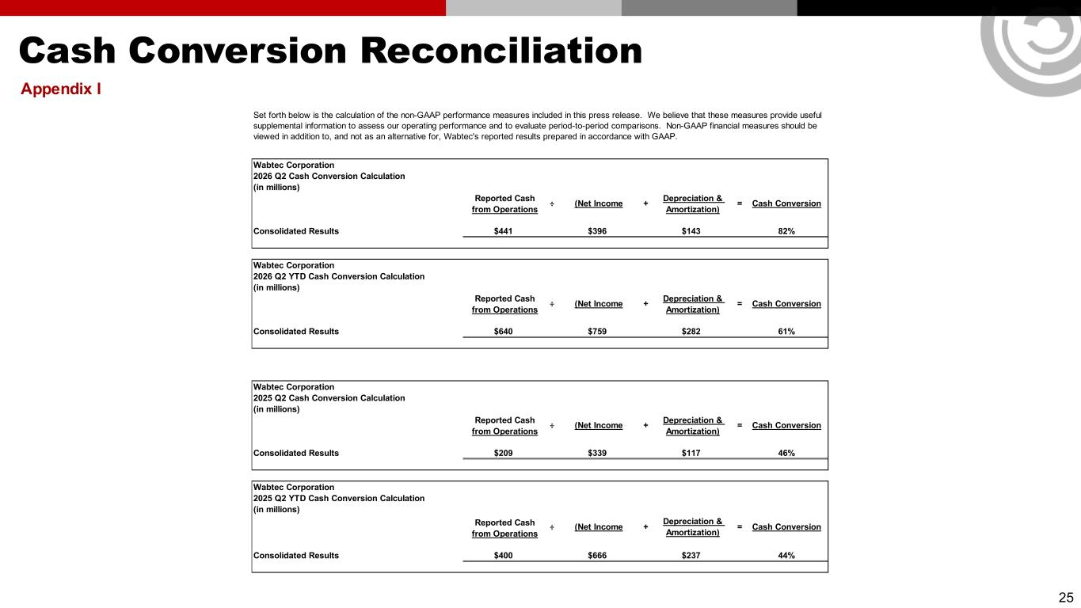
Cash Conversion Reconciliation Appendix I 25 Wabtec Corporation 2026 Q2 Cash Conversion Calculation (in millions) Reported Cash from Operations Consolidated Results $441 $396 $143 82% Wabtec Corporation 2026 Q2 YTD Cash Conversion Calculation (in millions) Reported Cash from Operations Consolidated Results $640 $759 $282 61% Wabtec Corporation 2025 Q2 Cash Conversion Calculation (in millions) Reported Cash from Operations Consolidated Results $209 $339 $117 46% Wabtec Corporation 2025 Q2 YTD Cash Conversion Calculation (in millions) Reported Cash from Operations Consolidated Results $400 $666 $237 44% Cash Conversion ÷ (Net Income + Depreciation & Amortization) = Cash Conversion ÷ (Net Income + Depreciation & Amortization) = Cash Conversion Set forth below is the calculation of the non-GAAP performance measures included in this press release. We believe that these measures provide useful supplemental information to assess our operating performance and to evaluate period-to-period comparisons. Non-GAAP financial measures should be viewed in addition to, and not as an alternative for, Wabtec's reported results prepared in accordance with GAAP. ÷ (Net Income + Depreciation & Amortization) = Cash Conversion ÷ (Net Income + Depreciation & Amortization) =

